working while disabled – social security can help

By Kirk Larson
Social Security Washington Public Affairs Specialist

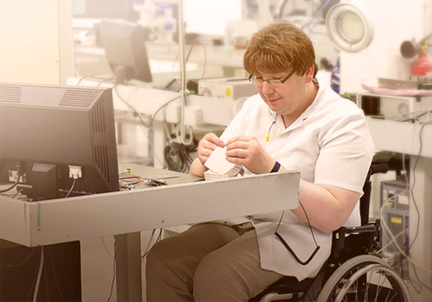
While it may be best known for retirement, Social Security is also here to help you get back to work if you are disabled. For millions of people, work isn’t just a source of income, it’s a vital part of who they are — it gives them purpose and pride — it’s a connection to community. If you’re getting Social Security disability benefits, we have good news for you. Social Security’s work incentives and Ticket to Work programs can help you if you’re interested in working. Special rules make it possible for people receiving Social Security disability benefits or Supplemental Security Income (SSI) to work and still receive monthly payments.

The Ticket to Work program may help you if you’d like to work. You can receive:

  - Free vocational rehabilitation;
  - Training;
  - Job referrals; and
  - Other employment support.

Read more about working while collecting disability benefits at www.socialsecurity.gov/work.
Work incentives include:

  - Continued cash benefits for a time while you work;
  - Continued Medicare or Medicaid while you work; and
  - Help with education, training, and rehabilitation to start a new line of work.

If you’re receiving Social Security disability benefits or SSI, let us know right away when you start or stop working, or if any other change occurs that could affect your benefits. If you returned to work, but you can’t continue working because of your medical condition, your benefits can start again — you may not have to file a new application.

You can read more about the Ticket to Work program in the publication titled “Working While Disabled: How We Can Help” at www.socialsecurity.gov/pubs/EN-05-10095.pdf.
Part of securing today and tomorrow is giving you the tools to create a fulfilling life. Getting back to work might be part of that. We’re here with a ticket to a secure tomorrow.

