APRIL IS NATIONAL SOCIAL SECURITY MONTH
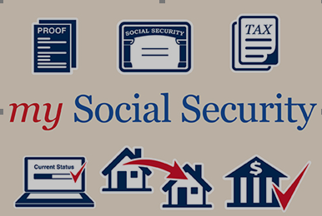
It’s National Social Security Month and this year we’re highlighting some of the time-saving features of the my Social Security account. Once you create an account, you’ll see that we already have your work history and secure information to estimate what you could receive once you start collecting benefits. With your personal my Social Security account, you can also:
- Request a replacement Social Security card;
- Set up or change direct deposit;
- Get a proof of income letter;
- Change your address;
- Check the status of your Social Security application; and
- Get a Social Security 1099 form (SSA-1099).
For over 80 years, Social Security has worked to meet the changing needs of the American public. Today, you can apply for retirement, disability, and Medicare benefits online, as well as take care of other business.
Knowledge is power. You care about your friends’ and family’s future, so encourage them to create a my Social Security account. Celebrate National Social Security Month by learning what you can do online anytime, anywhere at www.socialsecurity.gov/myaccount.
Sincerely,
Regional Public Affairs Office
Community Outreach
Social Security Administration
SEA.ORC.RPA@ssa.gov
