Social Security Honors and Supports Military Members
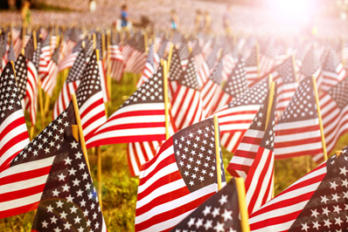

Every year, on Memorial Day, the nation honors service members who have given their lives for our freedom. Social Security acknowledges the sacrifice of our military’s service members, and we honor these heroes and their families who may need help through the benefits we provide.
Widows, widowers, and their dependent children may be eligible for Social Security survivors benefits. You can learn more about those benefits at www.socialsecurity.gov/survivors.
It’s also important to recognize those service members who have been wounded. Social Security offers benefits to protect veterans when an injury prevents them from returning to active duty or performing other work.
Wounded military service members can also receive expedited processing of their Social Security disability claims. For example, Social Security will expedite disability claims filed by veterans who have a 100 percent Permanent & Total compensation rating from the U.S. Department of Veterans Affairs (VA). Both the VA and Social Security have disability programs. You may find that you qualify for disability benefits through one program but not the other, or that you qualify for both. Depending on the situation, some family members of military personnel, including dependent children, and, in some cases, spouses, may be eligible to receive Social Security benefits. You can get answers to commonly asked questions and find useful information about the application process at www.socialsecurity.gov/woundedwarriors.
Service members can also receive Social Security in addition to military retirement benefits. The good news is that your military retirement benefit generally does not reduce your Social Security retirement benefit. Learn more about Social Security retirement benefits at www.socialsecurity.gov/retirement. You may also want to visit the Military Service page of our Retirement Planner, available at www.socialsecurity.gov/planners/retire/veterans.html.
Please share this information with a military family who may not know about these benefits. In acknowledgment of those heroes who died for our country, those who served, and those who serve today, we at Social Security honor and thank you.

