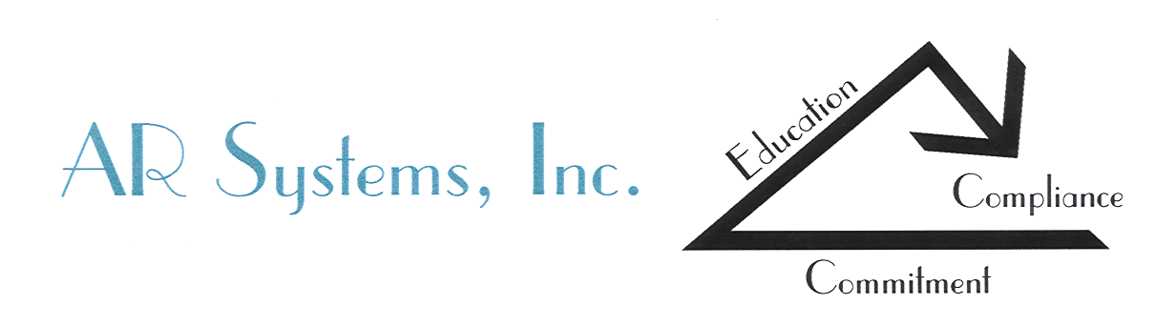

Finding HealthCare Solutions…together

Day Egusquiza

President, AR SYSTEMS, INC.
Presentations: call 208-423-9036
Daylee1@mindspring.com

Day Egusquiza brings over 40 years experience in health care reimbursement, hospital business office operations (20 years in an Idaho hospital), contracting, auditing and compliance implementation. Additionally, her experience includes eight years as a Director of a Physician Medical Management billing service which included completing an integrated business office between a hospital and a large multi-specialty physician clinic. She has been an entrepreneur in hospital and physician practice accounts receivable management and a leader in redesigning numerous organizations. Her work includes providing guidance as a compliance & reimbursement educator while providing operational insight on the revenue cycle impacts of disruption, lost charges, coding validation and yes, why I love Traditional Medicare’s 2 MN rule. Day’s strength is her ability to ‘operationalize’ complex regulations into teachable components.

Ms Egusquiza is a nationally recognized speaker on continuous quality improvement (CQI), benchmarking, redesigning, reimbursement systems and implementing an operational focus of compliance- both in hospitals and practices. She has been on the AAHAM National Advisory Council, HFMA National Advisory Council, is a past President of the Idaho HFMA Chapter & recently received the Lifetime Achievement Award. She has been highlighted in JCAHO’s Six Hospitals in Search of Excellence, Zimmerman’s Receivable Report, HFMA’s HFM and Patient Account, AHIA Prospective, and numerous healthcare newsletters along with a contributing author to 2006 Health Law and Compliance Update. She received the Idaho Hospital Association “Distinguished Service Award” for her legislative work and training on new indigent law. Attendees at HFMA’s ANI rated her in the top 25% for each year she has presented, earning her the ‘Distinguished Speaker’ award.

Her greatest accomplishments are her four wonderful children and her eight fabulous grandchildren.

What makes her unique? She has been in the trenches with us!

Points of Interest:

- AICPA: Planning Committee member for healthcare, Chair 2004-2011
Speaker at 14 annual conferences, board member 8 years
- AHIA: National conference key note speaker
- HFMA: National faculty member; presenter at ANI; national revenue cycle conference; two-day cluster; CFO Forums; regional conferences with continual evaluations in the top 25% -earning the Distinguished Speaker Award yearly.
- Instructor: College of Southern Idaho, continuing education program on “Understanding the Medicare Benefit.”
- Board of Directors: Special Olympics of Idaho,2003-2007. Secretary 2004
- Contributing Editor; AAHAM Technical Certification Study Guide, revised March 2004; CPAT & CCAT exams
- Co-Chair of national RAC Summit (2009-current)
- Co-Creator of the national Physician Advisor and UR Boot camp (2012-current)
- President and Founder of the Patient Financial Navigator Foundation, Inc, - a Idaho-based family foundation- transforming the hassle factor in healthcare thru education.

