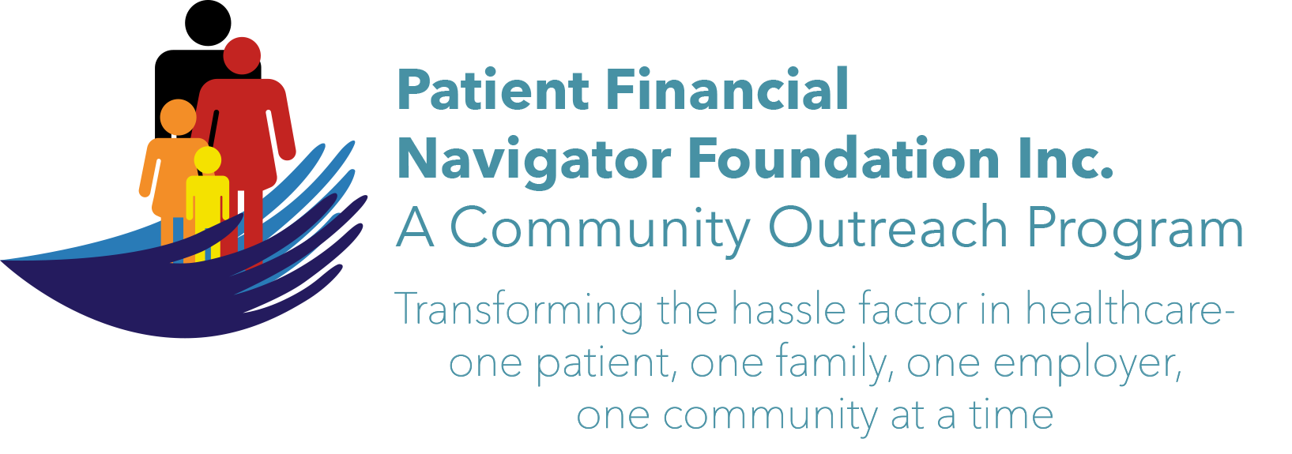

Welcome to the Dynamic New HealthCare Training
Foundation
Day Egusquiza, Founder and President of the Patient Financial Navigator Foundation, Inc/PFNF has more than 40 years of experience in healthcare revenue and reimbursement including 20 years in an Idaho hospital. She and the Advisory Board are excited to have created this Foundation in 2017 and are thrilled to bring these community outreach educational programs to the Magic Valley. PFNF is an Idaho-based, self-funded Family Foundation.

Overview of the Foundation
There are three unique elements within the education-focused Foundation provided at no cost.

Community Outreach  Networking with community resources to create healthcare educational sessions PLUS bi-monthly “HealthCare Buzz” publications in regional newspaper. | Employer Outreach  Creating ‘Lunch and Learn’ to address employer specific insurance questions – Health Savings Accounts/HSA, Insurance statements, Healthcare updates, out of network, etc. | Navigator Resource Library  Working with hospitals to create an onsite Resource Library that includes glossary of terms, tying employers to their insurance, answering Q&A of volunteers and family members.

Upcoming Community Outreach Boot Camp! Save the Date!
No cost. No pre-registration is required. ALL AGES ARE WELCOME! See you there!
1st 2020 Community Boot Camp
“Veterans Health Insurance Benefit Options-Turning 65 Boot Camp”

Tues, March 10, 2020 6:00-8:30 pm CSI Fine Arts

Subject experts will train on:
- Veteran’s Healthcare programs – eligibility overview
- National program updates
- Medicare 101 -Part A,B,C and Supplements
- Working with both VA and Medicare- examples
- Office on Aging Programs
- Senior Patrol & SHIBA
- Community outreach programs

For class material, go to http://PFNFinc.com. Questions? Call Day at 208 423 9036. Thanks a ton!

