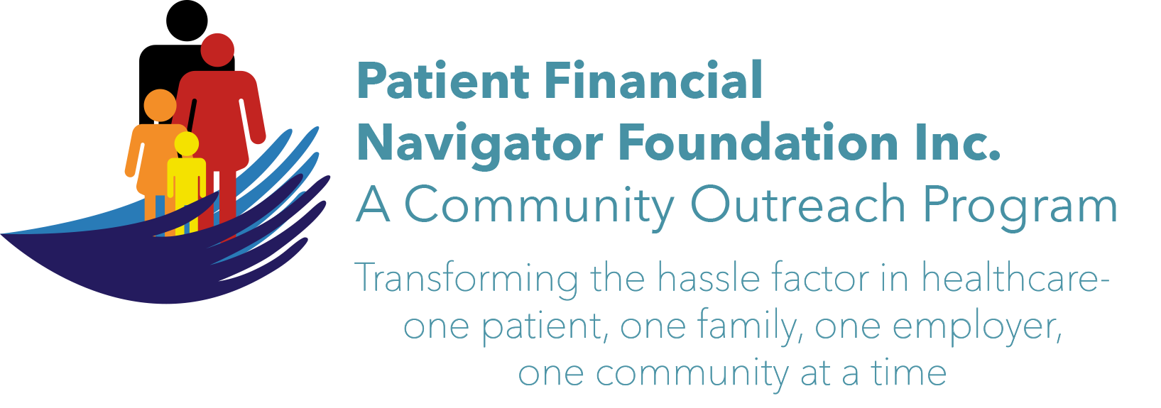
1st community outreach boot camp: “Turning 65 Boot Camp”
No cost to attend. No cost to faculty/businesses to participate.

Date: Sat, April 1, 2017 FINAL FINAL
Time: 8:30 am-1:30 pm
Location: CSI – 117/118 Shields building
All the public is invited

Tentative outline: DETAIL FOR FACULTY
Topic Time slot Presenter Content highlights
Healthcare Buzz | 8:30-9:00 am | Day Egusquiza | Glossary, DC potential changes
Medicare 101 -Part A, B, C, D plus Medicare Secondary payer | 9:00-10:00 am | Day Egusquiza/Foundation/AR Systems, Inc | CMS training on Medicare- ALL with $  Working at 65/MSP
Break | 10:00-10:20 am | Eagle’s nest | Vendor tables
Medicare Managed Care 101 | 10:20- 10:45 am  All 3 topics covered in 1 class. | Scott Standley/HUB International | Analysis – side by side, mgd vs traditional.
Supplemental insurance -to Medicare |  | Scott Standley/HUB International | What is normal out of pocket and role of supplementals
Major medical impact – what if I am still working past 65? |  | Trudy Dane & Toni Price/HUB International | If still working at 65, impact to employer’s insurance
Retirement $ | 10:45-10:55 am | Josh Rose/ DL Evans | Aver $ to retire; aver $ monthly
Investment strategies | 10:55-11:10 am | Lynn Hansen/Edward Jones | Diversified approach before and after retirement
Tax impact | 11:10-11:20 am | Dennis Brown/CPA | SS is taxable – why and how?
Break | 11:20-11:50 am | Eagle’s nest | Vendor tables
Social Security Program | 11:50 -12:00 am | SS Administration – Day to do | SSA provided material to cover
Aid for Aged/Blind/Disabled Medicaid | 12:00-12:15 pm | Laela Wilmot, Region 5&6 Benefits Mgr/Medicaid | Overview of the programs; how to access
Assistance programs for Seniors/SHIBA | 12:15-12:25 pm | Brad Talbutt/SHIBA Coordinator | Requirements to qualify; how to
Senior Programs | 12:25-12:40 p.m. | Shawna Wasko/Office on Aging | Programs, outline of services
Fit for Live | 12:40-12:50 pm | Shelly Wright /CSI | Staying fit – classes and daily
Wellness/healthy living | 12:50-1:00 pm | Keisha Angell/St Lukes | Healthy diet, daily
Advance Directives & Palliative Care | 1:00-1:15 p.m. | Jamie Kelly/St Lukes | What do the words mean? Have samples
In case you were getting bored:  Classes at CSI  Volunteering at St Lukes  Volunteering | 1:15-1:20 pm  1:20-1:30 pm  All volunteering – thru 1:30 pm | CSI  Kim Patterson & Rosemary Fornshell/St Lukes  Collin Randall/Visitor Center | Continuing ed options  Outline of what is done by the volunteers.  How to sign up, scope

