Welcome to the
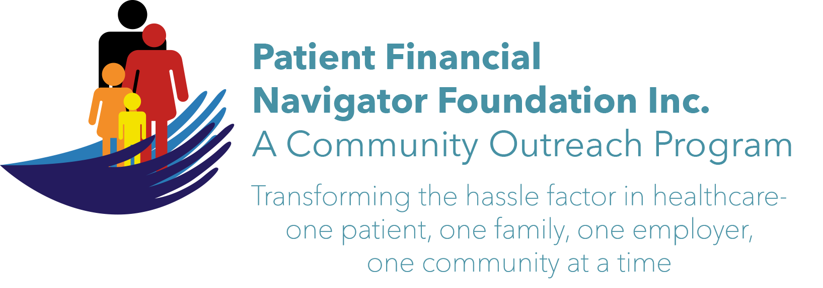
Day Egusquiza, Founder of the Patient Financial Navigator Foundation, Inc. and President of AR Systems, Inc. has more than 35 years of experience in healthcare including 20 years at an Idaho hospital. She and the advisory board are honored to create this Foundation and are thrilled to bring these community outreach educational programs to the Magic Valley!

At no cost to the attendees, we are excited to launch our 1st COMMUNITY Boot Camp:
“Turning 65 Boot Camp”

Date: Sat, April 1, 2017
Time: 8:30 am – 1:30 pm
Location: CSI Shields building (117/118)
All the community is invited

Exciting topics to be taught at the boot camp:
- Healthcare Buzz – what is happening in DC
- Medicare 101 – Part A, B, C, & D overview
- Managed Medicare vs Traditional Medicare
- What if I am still working? Insurance impact plus Medicare impact
- Investment strategies plus cost to retire?
Tax impact
- Social security
- Low income Seniors – is there help?
- Office on Aging
- Fit for Life
- Wellness/Healthy Living
- Advance Directive and Palliative Care
- Volunteering
- Continuing CSI opportunities
+++ opportunities to learn more from all the excellent faculty thru networking breaks++++

We look forward to seeing you at our 1st Boot Camp! THANKS A TON. Here we go!

Day Egusquiza, Founder
Like us on Facebook: PFNFInc. Webpage short cut: http://bit.ly/2lm/1Qi
Twitter: #ptnavigator.

