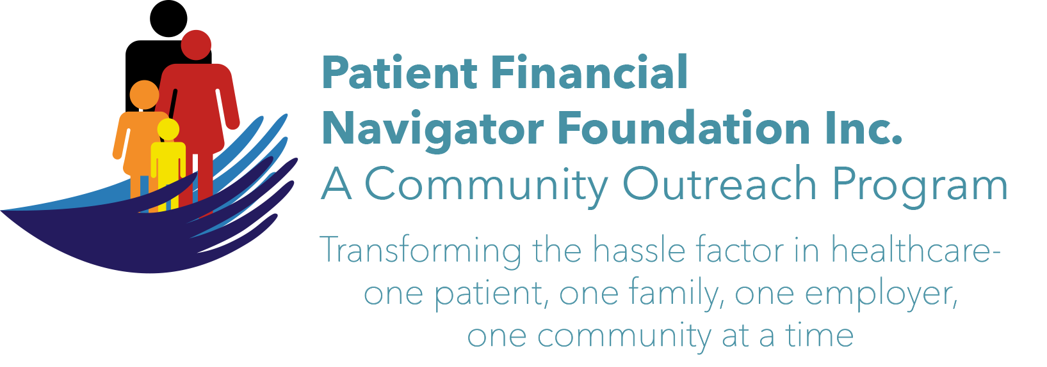 Article for HealthCare Buzz
Times News. Jan 2019
Article – 25
Plan for 2019
As we look to 2019, we have some exciting topics we will be tackling. We would love to hear from you regarding ideas, topics, and questions about crazy healthcare issues as transforming the hassle factor in healthcare thru education is the mission of the Patient Financial Navigator Foundation.
We anticipate multiple articles for 2019 in the following categories:
Scams- all shapes and sizes. Wow – it would be great if we didn’t have to include this topic, but they continue and are impacting millions. As an example, over the Christmas season, local TV stations carried the ‘grandparent calls with grandchildren in financial peril’. These hit our hearts and make us more vulnerable to scams. Another one - CNN ‘s story: “Why robo calls are about to get more dangerous” – 25 million became victims. As a last resort –if you don’t know the number, don’t answer.” (We will definitely be covering more about this in future articles.)

Definition of healthcare terms - in our bi-annual community Boot Camps, we are continually asked about ‘terms’. Our community does not understand many healthcare terms, even though we have much more access to information. If you are not in the healthcare field, it can just be overwhelming. We will tackle a glossary of terms while trying to operationalize each item – i.e. what does this really mean to the patient? With so much healthcare news- both nationally and locally – we will work to keep it simple while providing patient-centered education. (It is hard to be engaged if you don’t understand everything going on around you.)

Community Outreach – Healthcare is personal. Healthcare is local. As part of the Foundation’s commitment we will be hosting two community Boot Camps. Save the dates: Sat, March 16th and Sat, Sept 28th. Topic: “Medicare 101, Social Security Benefits and Assistance for Seniors.” No cost, CSI Fine Arts, 8:30 am-12noon. We will also be continuing our employer outreach thru partnering with the Small Business Development Center/SBDC for the “All Employer Healthcare Summit.” Dynamic way to learn all about the newest healthcare ‘disruptions’. Do you have a need for education in your business or school? Drop us a note and let’s get connected.

Excited to continue the Healthcare Buzz educational process in 2019! Here we go!

All historic articles & training material are available on the Foundation’s webpage: PFNFInc.com. Day Egusquiza is the President & Founder of the Patient Financial Navigator Foundation, Inc- an Idaho-based, Family Foundation. (Do you have a topic for Healthcare Buzz? Please share at daylee1@mindspring.com. THANKS!)

