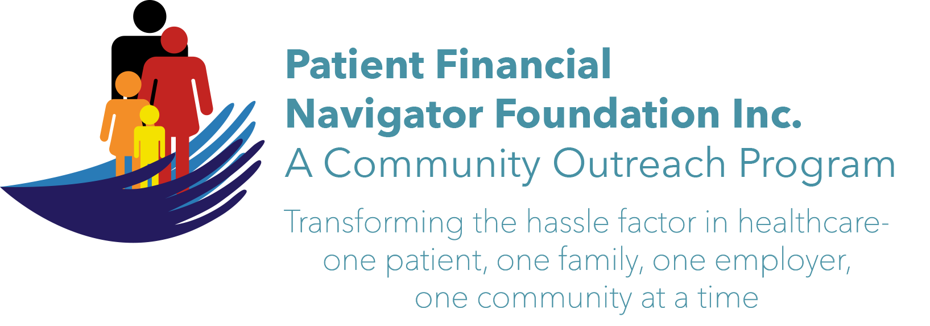

Welcome to the 2nd 2017 Community Outreach Boot Camp-
Medicare 101, Social Security Benefits and Assistance for Seniors

Date: Thurs, July 6th
Time: 12:30- 5:00 pm
Location: Fine Arts, CSI Campus

Training Agenda:
Topic | Time | Presenter
Welcome to the Foundation; Mission and Overview/Training | 12:30-1:10 pm | Day Egusquiza, President and Founder of PFNF, Inc.
Medicare 101 – A, B, C, D and Medicare 2nd payer – making it real | 1:10-2:00 pm | Day Egusquiza
Medicare Advantage/Part C – how it works, options, etc.  Medicare Supplemental Insurance – for the out of pocket expenses | 2:00-2:30 pm | Scott Standley, HUB International
Break | 2:30-2:50 pm | Eagle’s Nest
Social Security Benefits | 2:55-3:20 pm | Greg Brusick, District Mgr, SSA
Aid for Blind, Disabled – H&W | 3:20-3:40 pm | Laela Wilmot, Mgr, H&W
SURPISE Fitness Break | During this period | Fit for 60
Office on Aging | 3:40-4:05 pm | Shawna Wasko, PI/Contract Mgr
AARP | 4:05-4:15 pm | AARP**Invited
FINAL PANEL FOR Q&A | 4:20-4:45 pm | All faculty, plz
FINAL opportunity/Eagles | After the Q&A | THANKS A TON! Day

