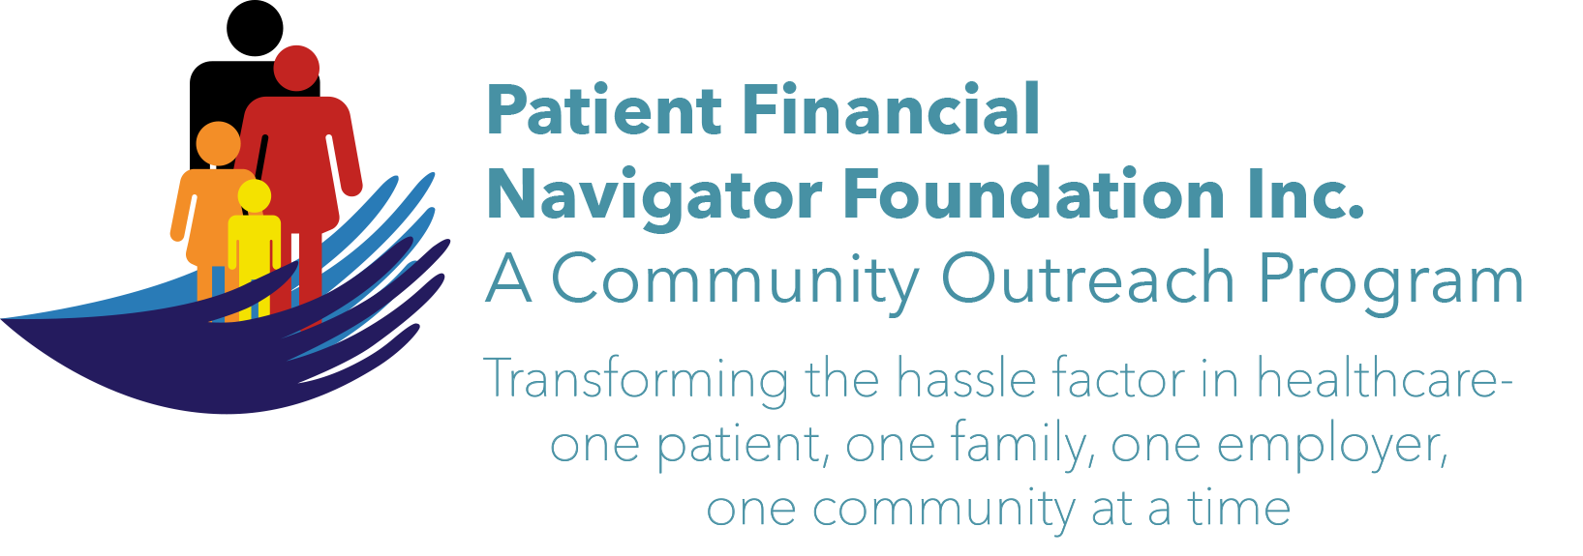

Welcome to the dynamic new healthcare training Foundation!

Day Egusquiza, Founder & President of the Patient Financial Navigator Foundation, Inc/PFNF has more than 38 years of experience in healthcare including 20 years in an Idaho hospital. She and the Advisory Board are excited to create this Foundation and thrilled to bring these community outreach educational programs to the Magic Valley! *PFNF is an Idaho-based, Family Foundation*

Overview of the Foundation
There are three unique elements within the educational-focused Foundation provided at no cost.

Community Outreach  Networking with community resources to create healthcare educational sessions PLUS ongoing HealthCare Buzz updates. | Employer Outreach  Creating “Lunch and Learn’ to address employer specific insurance questions – Healthcare Savings Accounts/HSA, EOBs, Healthcare Buzz, more. | Navigator Resource Library  Working with the local hospital to create an onsite Resource Library with local insurance plans, Q&A on ‘what happens now”, local references, glossary of terms, more.

Upcoming Community Outreach Boot Camps! Save the Date! All the public is invited.
No cost. No pre-registration is required. ALL AGES ARE WELCOME. See you there!
3rd 2018 Boot Camp:
“Preparing to Turn 65 Boot Camp

Sat, Nov 3rd 8:30-1:00 pm CSI Fine Arts
Subject experts will train on:
- Medicare 101 – Part A, B, C, D and Medicare as secondary payer.
- Medicare Advantage vs Traditional Medicare
- Supplemental insurance costs & needs
- Social Security Benefits
- Aid for Aged, Blind and Disabled (Medicaid)
- Tax impact
- What does it cost to retire?
- Office on Aging Programs
- SHIBA
- Fit after 60!
- Safety in the home
- Palliative – end of life decisions
- Stay active - Volunteerism


We would love to have you join us!
For continuing updates - Facebook.com/PFNFInc and the webpage: http://PFNFInc.com or call 208 423 9036

