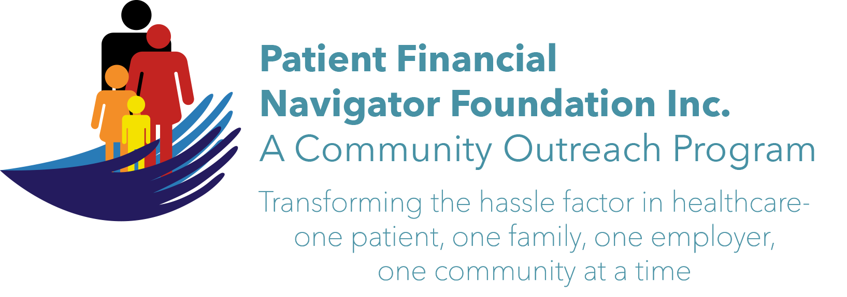

3rd 2017 Community Outreach Boot Camp: “Turning 65 Boot Camp”
No cost to attend. No pre-registration is required. Call Day at 208 423 9036 or go to PFNFInc.com for more info. All classes are available on the webpage prior to the actual boot camp.

Date: Sat, Oct 28, 2017
Time: 8:30 am-1:30 pm
Location: CSI Fine Arts
All the public is invited

Welcome to PFNF & Healthcare Buzz
Medicare 101 -Part A, B, C, D plus Medicare Secondary payer
Medicare Advantage 101
Supplemental insurance to Traditional Medicare
Social Security Benefits
Aid for Aged/Blind/Disabled Medicaid
Tax impact
Retirement Costs
Assistance programs for Seniors/SHIBA & Scams
Office on Aging- programs

Fit for Life
Wellness/healthy living
Community Health
Advance Directives & Palliative Care
Volunteering at St Lukes

