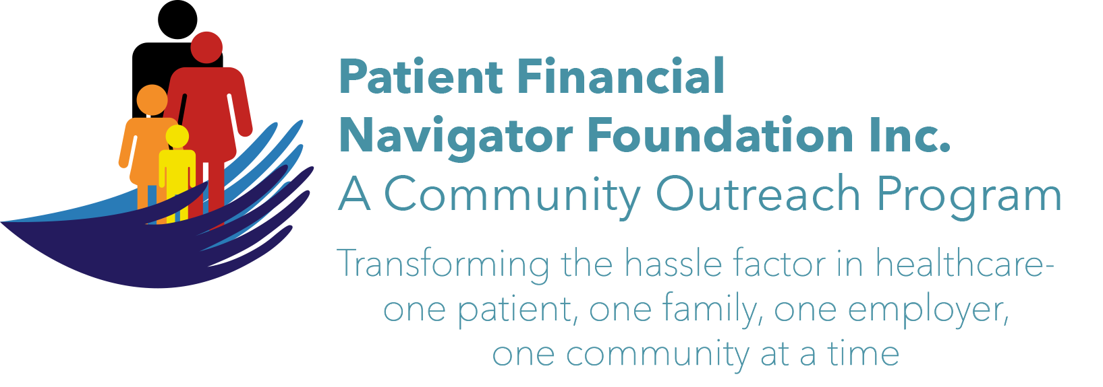 Article for HealthCare Buzz
Times News. Jan 2018
Article – 9
Turning 65: Annual Wellness Visits
Turning 65 has health benefits such as the Traditional Medicare approved Annual Wellness Visits (AWV). The yearly coverage is for Traditional Medicare patients, 65 or older, and is 100% covered with no co-payment or deductible under Part B/outpatient and physician coverage. Limitations: Beneficiaries cannot be within their first 12 months of their first Medicare Part B coverage and have not received an Initial Preventive Physical Examination (IPPE) within the past 12 months. (Essentially 13 months after turning 65 they can begin.)
The elements that a provider/physician must provide: Health Risk Assessment/HRA while identifying ‘gaps in their preventive care’ which could expose them to falls, other accidents and possible serious infections. EX) The Assessment ensures all immunizations and cancer screening are current. Subsequent AWVs continue with updates to the HRA including changes with living conditions, mental status along with support systems for the senior.

A Lakeland, FL provider group reported that thru this Annual Wellness visit they saw a 40% decrease in hospitalizations. Beneficiaries are staying healthy with at risk issues identified and action taken BEFORE the problem occurs, i.e. gaps… The cost of healthcare after age 65 continues to have serious financial impacts. The AWV helps reduce the cost of preventable occurrences.

NOTE: This is not a routine physical checkup that some seniors may get every year. Medicare does not cover routine physician examinations; thus is it is very important to clearly ask for the Annual Wellness Visit when scheduling to see your physician. The physician may order an EKG or other lab work during this visit based on the assessment. Any additional diagnostic services will have the coinsurance due and will be applied to the Part B yearly deductible prior to payment by Traditional Medicare. The AWV is at no cost.
To get more information, go to Medicare/CMS’s webpage: http://www.cms.gov/Outreach-and-Education/Medicare-Learning-Network-MLN/MLNMattersArticles/Downloads/MM7079.pdf

Is healthcare complicated? The payment system is different for each insurance plan, Medicaid/per state and Traditional Medicare vs Managed Medicare/Medicare Advantage. Learn more about all the areas of impact thru the 1st 2018 Patient Financial Navigator Community Boot Camp: “Medicare 101, Social Security Benefits and Assistance for Seniors” Sat, Feb 3rd CSI Fine Arts. 8:30 am-12:30 PM. No Cost! No pre-registration is required! Let us help reduce the hassle factor thru education. (Day Egusquiza is the President & Founder of the Patient Financial Navigator Foundation, Inc- an Idaho-based, Family Foundation.)

