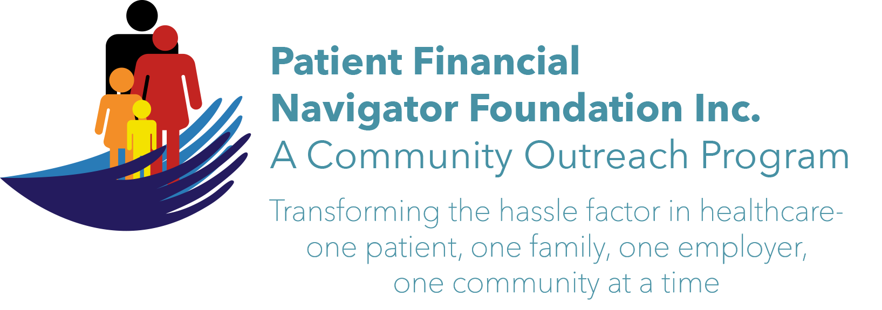 Article for HealthCare Buzz
Times News. Oct 25, 2018
Article – 20
Turning 65: New Medicare cards have started in Idaho
In 2015, Congress required the removal of Social Security Numbers (SSN) from all Medicare cards by April 2019. A new Medicare Beneficiary Identifier (MBI) will replace the SSN-based Health Insurance Claim Number (HICN) on the new Medicare card. The MBI should be used like the SSN with healthcare providers to submit healthcare claims and other beneficiary-specific information. Why are the new cards important? The biggest reason is to fight identify theft with Medicare. The new card will look very different than the current SSN. It will be 11 characters in length, made up only of numbers and uppercase letters. (EX: 1EG4-TE5-MK72) No benefits will change. There is no cost for the card. The new card can be used when it is received.

What’s the timeline for the new Medicare cards and what does it mean for the beneficiary?
New cards with new numbers will begin to be sent in late summer/early fall 2018 to Idaho seniors. They are here! Don’t be nervous if your neighbor or your spouse gets their new card and you didn’t. It is a random rollout. It is important to ensure the mailing address is correct. There will be a rollout period to allow time for all Medicare beneficiaries to receive their new cards –thru April 2019. Either card can be used thru a transition period but to ensure deductibles are easily applied – it is recommended to use the NEW Medicare card when received. Your healthcare provider can help with questions as the rollout for the new cards begin. It will take some adjustment as the SSN has been used since the beginning of Medicare, 1965.

We will be discussing the new cards along with recommendations at the 3rd 2018 Community Outreach – “Preparing to Turn 65 Boot Camp.” All ages are welcome as we learn together. No cost and no pre-registration is required. See you on Sat, Nov 3rd at CSI Fine Arts from 8:30-1:00 pm Look for the “BOOTCAMP” sign.

(Day Egusquiza is the President & Founder of the Patient Financial Navigator Foundation, Inc- an Idaho-based, Family Foundation. Questions? Call Day at 208 423 9036)

