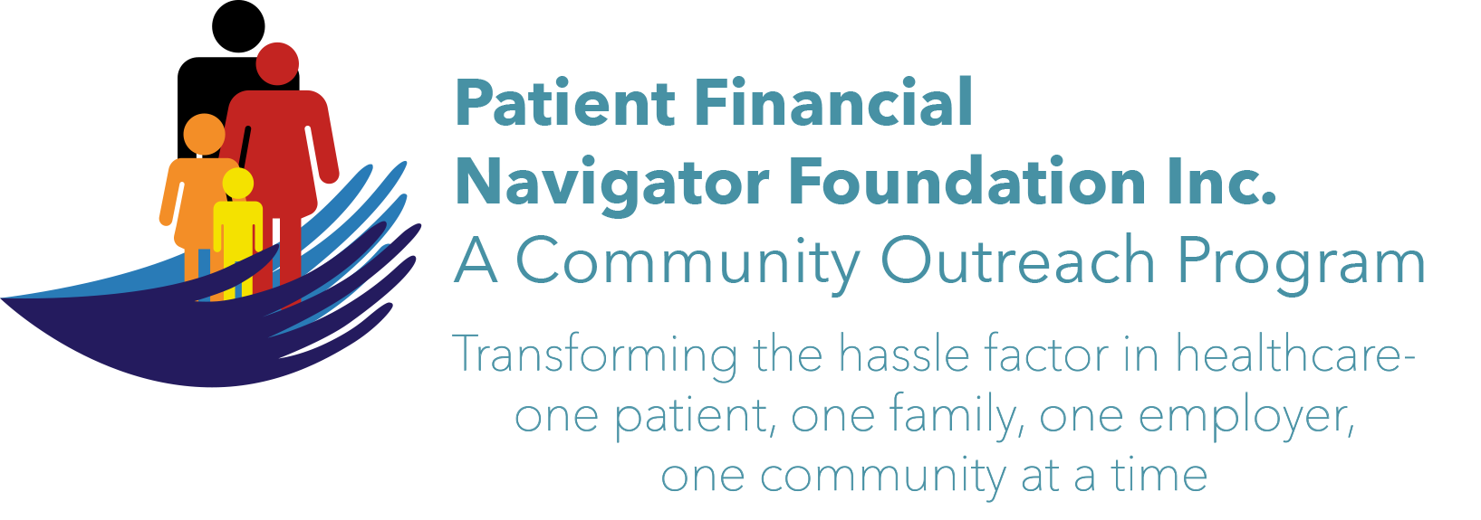 Article for HealthCare Buzz
Times News. July 2018
Article – 18
Turning 65: Safety in the home – Part 3
In Part 3 of our safety in the home series, Bryan Wright, President and CEO of Wright Physical Therapy, shares the remaining two of the four elements of injury prevention which is the key to healthy living. (The first two were covered in June’s Healthcare Buzz articles.)
Safety in the home can have a different meaning depending on the stage of life you are in. After the age of 65, falls become the most significant cause of death in the home. As in all cases of health and safety for your life, prevention of injury is the key to healthy living. Tips three and four conclude Bryan’s advice.
3rd: Deep strength in the core of your spine is important to overcome pain and injury. Many simple daily exercises can and should be incorporated into your routine to fortify your deep layer strength.
4th: Our habits of daily living can and should be adapted to healthier lifestyle choices as time goes. Some simple tips for everyday safety include installing supports in your bathroom and kitchen, stabilizing staircases, clearing steps around your home, getting good rest through the night and incorporating a daily exercise routine that brings you enjoyment.
In all of Bryan’s studying of preventing injury and improving quality of life, there is a common denominator: exercise is the keystone habit. Exercise is responsible for decrease in fall risk, injury risk, lower morbidity and mortality rates, decreased risk for cancer of various kinds, reduction in diabetes prevalence and side effects, increase in bone density, increase in mood and self-confidence and the list goes on. Bryan’s final advice is to reach out to professionals to customize your lifestyle change for the most effective benefits but any movement is beneficial. An ounce of prevention is worth far more than a pound of cure. “Motion is lotion.”

Note: CSI’s Fit After 60 program is an excellent way to do moderate movement and activities. Fit after 60 representatives keep us moving at every Boot Camp – from simple arm movements to leg lifts to bending – all with a goal of ‘motion is lotion.’

All historical class material is available at PFNFinc.com.

(Day Egusquiza is the President & Founder of the Patient Financial Navigator Foundation, Inc- an Idaho-based, Family Foundation. All class material from previous Boot Camps are on PFNFinc.com’s webpage)

