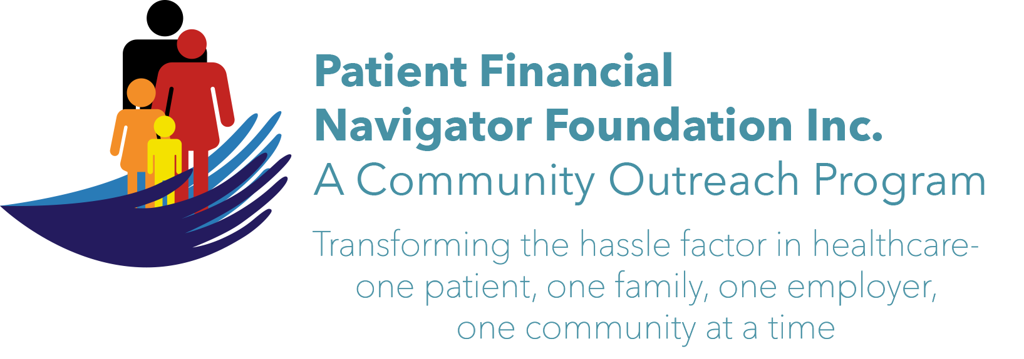 Article for HealthCare Buzz
Times News. June 2018
Article – 18
Turning 65: Safety in the home – Part 2
In Part 2 of our safety in the home series, Bryan Wright, President and CEO of Wright Physical Therapy, has shared additional safety tips.
Safety in the home can have a different meaning for you depending on the stage of life you are in. For example, motor vehicle accidents take more lives of children, adolescents, teenagers and young adults aged 1-24. From ages 25-64, drug overdose and opioid abuse is tragically the top cause for lives taken. After the age of 65, falls become the most significant cause of death in the home.
When comparing home safety statistics to workplace causes for injury, there are scary similarities. The top two causes for approximately 50% of all injuries at work are caused by overexertion (refer to the Part 1 article from June 9th) and slips, trips and falls. Due to these injuries that cause pain or disability, falls and drug abuse can become much more prevalent. It becomes our duty and opportunity to do what we can to prevent these problems from happening to each of us and our families.
As in all cases of health and safety for your life, prevention of injury is the key to healthy living and substantial healthcare savings. We will discuss two of the four keys in part 2 and will wrap up this exceptional educational series with the remaining two in our next series.
- Motion is lotion – this basically means that choosing movement over being sedentary will help you in countless ways. Embrace motion in your life to keep yourself moving more smoothly.
- Nerves need three things to be happy including blood flow, space and movement – gentle and dynamic nerve stretches can be powerful in preventing pain and injury.

Note: CSI’s Fit After 60 program is an excellent way to do moderate movement with many of your age peers. Fit after 60 representatives keep us moving at every Boot Camp – from simple arm movements to leg lifts to bending – all with a goal of ‘motion is lotion.’

(Day Egusquiza is the President & Founder of the Patient Financial Navigator Foundation, Inc- an Idaho-based, Family Foundation. All class material from previous Boot Camps are on PFNFinc.com’s webpage)

