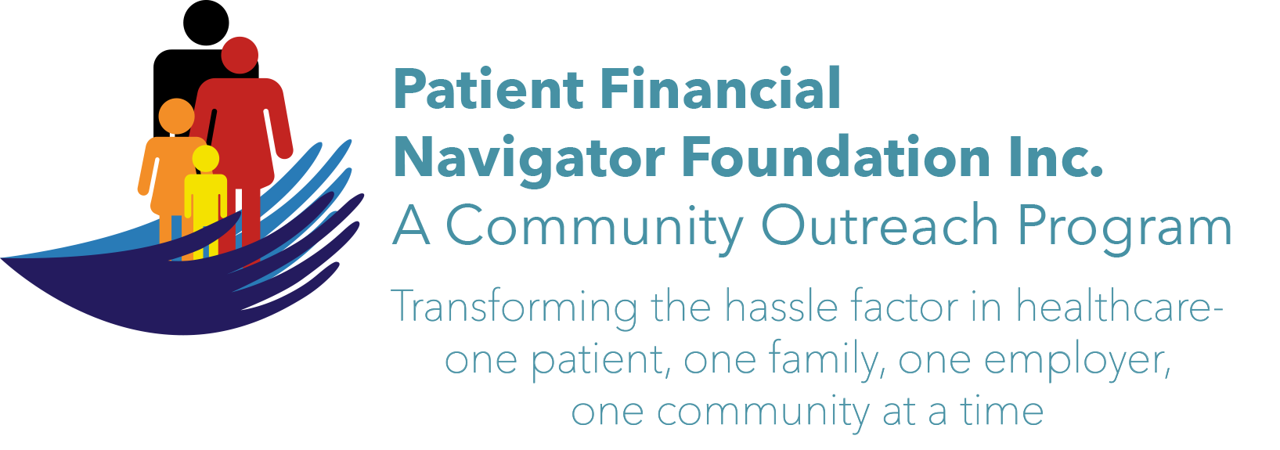 Article for HealthCare Buzz
Times News. March 2018
Article – 12
Turning 65: SCAMS – Part 3
“If you spot a scam…Tell Someone. Then tell the Federal Trade Commission/FTC.” Tiana Hudson, Insurance Specialist, Office on Aging, CSI is an excellent source to discuss potential scams. (208 736 2122 x 2124) To stop the many scams in the community, report them directly to FTC. Electronically-ftc.gov/complaint or call them 1-877-FTE-HELP. In this 3rd Scam article, we will highlight the 10 things from the FTC to do to avoid fraud.
- Spot imposters. Scammers often pretend to be someone you can trust, like a government official, family member, a charity, or a company you do business with. Don’t send money or give out personal information in response to an unexpected request. (Hang up – call the individual or company and ask them if there are questions.)
- Do online searches. Type a company or product name into your favorite search engine with words like ‘review,’ ‘complaint’, or ‘scam.’ Or search for a phrase that describes your situation, like “IRS call.’ (IRS always uses the post office/letters, not calls.)
- Don’t believe your caller ID. Technology makes it easy for scammers to fake caller ID information, so the name and number you see aren’t always real. (Don’t answer or rapidly hang up)
- Don’t pay upfront for a promise. Someone might ask you to pay in advance for the things like debt relief, credit and loan offers, mortgage assistance or a job. They might even say you’ve won a prize, but first you have to pay taxes or fees. Learn how to get help at consumer.ftc.gov.
- Talk to someone. Slow down and talk to someone you trust before doing anything. Con artists want you to hurry and make a decision. They may even threaten you. (Hang up…)
- Consider how you pay. Someone might ask you to pay in advance for things like debt relief, credit and loan offers, mortgage assistance, or a job. Wiring money is risky because its nearly impossible to get your money back.
- Hang up on robocalls. If you answer the phone and hear a recorded sales pitch, hang up and report it. These calls are illegal.
- Be skeptical about free trial offers. Some companies use free trials to sign you up for products and bill you every month until you cancel. Research before signing up. Check monthly statements for charges you don’t recognize.
- Don’t deposit a check or wire money back. If a check you deposit turns out to be fake, you will be responsible for paying back the bank. (Emails from Nigeria or other lottery winnings that need deposited – think scam.)
- Sign up for free scam alerts from the FTC at FTC.gov/scams.

Be alert. Be aware. Check your credit report every year: Free report from AnnualCreditReport.com
Protect your Social Security number. Don’t give any financial information …ever. If you don’t know the number calling, don’t answer it. If it is an important call, they can leave a message or call back.

Join us! “2nd 2018 Medicare 101, Social Security Benefits and Assistance for Seniors Boot Camp” – Sat, June 9th. 8:30 am – 12:30 pm FREE. CSI Fine Arts. No pre-registration is required. Call Day at 423 9036 for more information. All articles & training material are available on the Foundation’s webpage: PFNFInc.com. Day Egusquiza is the President & Founder of the Patient Financial Navigator Foundation, Inc- an Idaho-based, Family Foundation.

