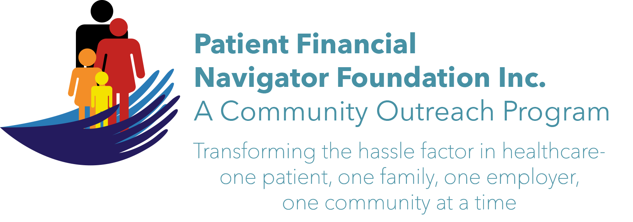 Article for HealthCare Buzz
Times News. March 2018
Article – 11
Turning 65: SCAMS – Part 2
Beware of the continuing sophistication of the ‘scams’ that the Federal Trade Commission outlines. In addition to the five scams from Part 1 of the 3-part series, the following additional scams are being used to commit fraud to unsuspecting seniors (and others.)
- Sweepstakes & Grant Scams. The sweepstakes will be awarded if you send money to get the funds transferred or sent to you. Never pay to collect a so-called prize or grant. Legit sweepstakes don’t make you pay a fee. (www.consumer.ftc.gov/articles/0199-prize-scams)
- Family Emergency Scams. These are especially cruel as they lead the family member to believe someone has been hurt or in a threatening situation. Slow down, get off the phone and check with a family member or friend – even if the caller says it is a secret or tells you not to contact anyone. Do not wire money or buy a prepaid card or a gift card. (www.consumer.ftc.gov/articles/0204-family-emergency-scams.)
- Charity Scams. “…thank you for your kind and generous donation on behalf of the Children’s Cancer Fund of America. You’re helping these children with their hospice equipment, medical supplies and medication….” Hang up or “I didn’t give any money’ and never give money over the phone.
- Unwanted/robo calls. Robocalls are more than just annoying: they are illegal. The Federal Trade Commission/FTC has sued operations selling: medical alert and home security systems, interest rate reduction services, auto warranties and free vacations. Report them: DoNotCall/gov or call 1-888-382-1222. Don’t trust called ID-easy to spoof – looks like a local call/same area code.
- Opportunity Scams. ‘ Invest today-start earning tomorrow!’ Check the company’s record. Avoid high pressure testimonials.
Be alert. Be aware. Check your credit report every year: Free report from AnnualCreditReport.com
Protect your Social Security number. Don’t give any financial information …ever. If you don’t know the number calling, don’t answer it. If it is an important call, they can leave a message or call back.
Report all ‘attempts ‘to the Federal Trade Commission, 1-877-FTC-HELP.
Or contact Ms Taenia Hudson at Office on Aging for support or questions. 208 736 2122 ext 2124.

Watch for Part 3 coming soon. All training material is available on the Foundation’s webpage: PFNFInc.com. (Day Egusquiza is the President & Founder of the Patient Financial Navigator Foundation, Inc- an Idaho-based, Family Foundation.)

