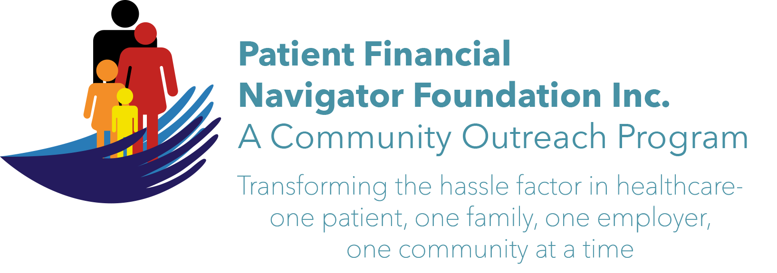 Article for HealthCare Buzz
Times News. Dec 2017
Article – 8
Turning 65: Retirement challenges =healthcare costs
In a recent survey, Merrill Lynch partnered with Age Wave to gain insight into retirement.
With 10,000 seniors turning 65 daily as the baby boomers have ‘come of age’ – it is important to prepare for retirement. The survey found three important findings:
- 81% of Americans say they don’t know how much they will need for retirement.
- Their #1 ingredient for happiness is their health.
- 72% of people worry about serious health in their retirement.

The cost of retirement includes an understanding of the average Social Security payments and average lifespan which is different for men and women. As of Dec, 2016 - Average monthly Social Security/SS payment for men is $1524; for women $1209. There will be multiple healthcare deductions from the monthly SS payment (Part B and Part D) plus recommended Medicare supplemental insurance to help defray the out of pocket expenses associated with Traditional Medicare. As retirement budgets are developed, seniors should use an average of $300 for these monthly premiums. This will significantly reduce the amount remaining for living expenses, entertainment, and out of pocket/patient portion payments for all Medicare plans. (EX: $1209- $300 = $909/Women left for all budgeted expenses and unexpected healthcare costs.) With women living until 81 and men until 76, considerable attention needs made for current healthcare costs and potential deteriorating healthcare chronic conditions; all resulting in additional costs deducted from the Social Security monthly payment. Social Security = monthly checks, most starting at 67. Medicare = coverage for healthcare at 65 for most Americans.

Additionally, an average of 19% of all Americans indicate they will be working beyond 65. This is the highest since the 1960s. If a person turning 65 is still working, it is important to thoroughly assess their major medical coverage thru their employer as it will be primary to Medicare. If you are retiring BEFORE turning 65, there will be no Medicare coverage. It is the biggest ‘hidden’ cost – finding ‘gap’ insurance – usually only available thru the Exchange with varying individual coverage rates.

Is healthcare complicated? The payment system is different for each insurance plan, Medicaid/per state and Traditional Medicare vs Managed Medicare/Medicare Advantage. Learn more about all the areas of impact thru the 1st 2018 Patient Financial Navigator Community Boot Camp: “Medicare 101, Social Security Benefits and Assistance for Seniors” Sat, Feb 3rd CSI Fine Arts. 8:30 am-12:30 PM. No Cost! No pre-registration is required! Let us help reduce the hassle factor thru education. (Day Egusquiza is the President & Founder of the Patient Financial Navigator Foundation, Inc- an Idaho-based, Family Foundation.)

