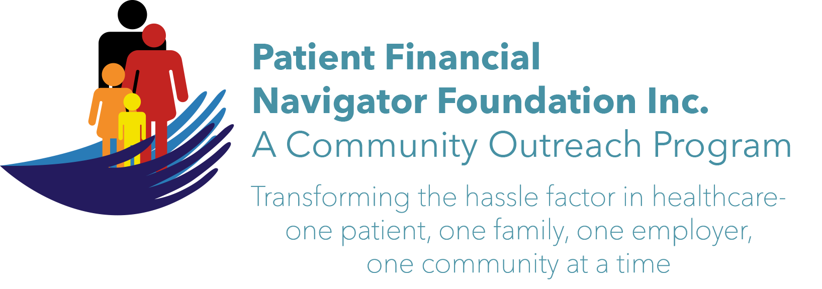 Article for HealthCare Buzz
Times News. Dec 2018
Article – 23
Turning 65: Attacking the Holiday Blues- Part 1
“Merry Christmas”, “Happy Holidays”, “Wonderful to see you”, “Let’s not let so much time pass before we see each other.” Wonderful holiday greetings which are usually accompanied by a) an acquaintance handshake, or b) a friendly, quick hug or the all-time best, c) a bear hug embrace – all part of a culture of ‘connecting’. Verbal and physical connecting add to our general mental health – but attacking the holiday blues requires a bit more.

In this 2-part series, we will share some powerful ideas on how to curb the holiday blues as loneliness can be toxic. And then add in feelings of being overwhelmed with too many expectations or trying to find a way to participate in the season of joy and celebration when you just don’t feel like doing anything. Sadness, self-reflection and anxiety are the holiday ‘norm’ for too many.
Enter the power of volunteerism in America.

Rosemary Fornshell, President of the Ancillary at St Luke’s Magic Valley, shared some great insight into the power of volunteerism. “Volunteerism is an American value. In fact, we are a nation of volunteers. I love this quote: ‘If you want to lift yourself up, lift up someone else.”- Booker T Washington. Volunteers give of themselves in terms of work and time. They get back a sense of belonging and worth and so much more. Just ask a volunteer and they will tell you they get more than they give. Volunteers in the United States are 63 million strong and hold up the foundation of civil society. They help their neighbors, serve their communities and provide their expertise. No matter the kind of volunteer work, they are contributing in invaluable ways.

From Luke Smith, LMSW at the Cognitive Behavioral Therapy Primary Counseling, ‘Ways to cope with loneliness over the holidays.”
- Plan ahead and reach out. If this is your first holiday away from home, in a new city, or alone for the first time- look for events and schedule in advance to attend. Gives you something to look forward to!
- If there are days that may be especially difficult for you – plan a ‘check-in’ with friends and family. Create a new holiday ‘norm.’
- Look for ways to volunteer during the holidays.
Lastly, do a quick internet search: Volunteers needed in the Magic Valley. WOW!
Ideas like: People for Pets, Office on Aging, Shut-ins, or think about the nursing homes with patients who may not have any local family. You can do it and enrich your lives and theirs.

All historic articles & training material are available on the Foundation’s webpage: PFNFInc.com. Day Egusquiza is the President & Founder of the Patient Financial Navigator Foundation, Inc- an Idaho-based, Family Foundation. (Do you have a topic for Healthcare Buzz? Please share at daylee1@mindspring.com. THANKS!)

