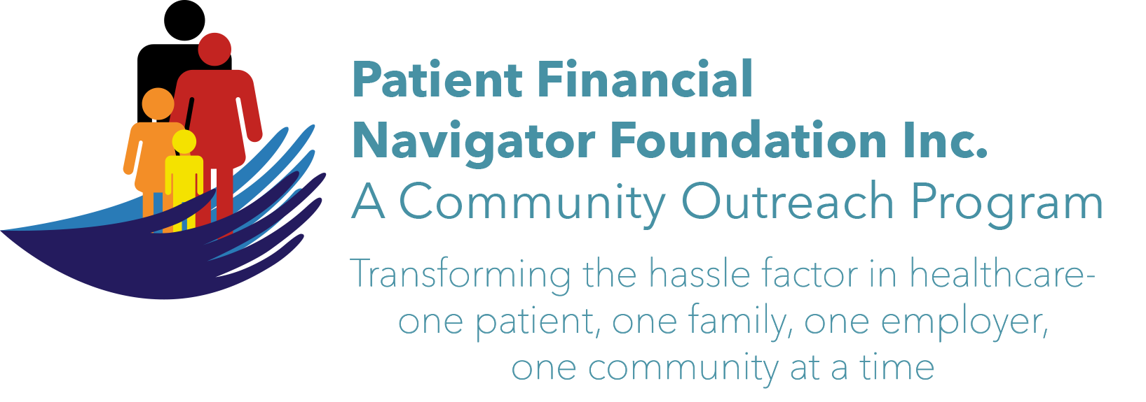 Article for HealthCare Buzz
Times News. Dec 2018
Article – 24
Turning 65: Attacking the Holiday Blues- Part 2
As we prepare for the special holiday celebration, let’s finish our two-part series on attacking the holiday blues. The holiday season for many is filled with celebrations, social gatherings with family and friends. For many others, it is a time filled with sadness, self-reflection, loneliness and anxiety. Let’s “attack loneliness”. Loneliness is toxic. Dr Vivek Murthy, former US Surgeon General, says the reduced life span linked to loneliness is similar to smoking 15 cigarettes a day. Wow! Remember – loneliness is subjective. Loneliness does not mean being alone; loneliness does not mean not having friends. Dr Jeste, director of UC San Diego’s Center for Healthy Aging shares: “Loneliness is defined as subjective distress. It is the discrepancy between the social relationships you want and the social relationships you have.”

WebMd’s “Holiday Depression & Stress” lists 19 tips for copying with holiday stress and depression.
- Make realistic expectations for the holiday season.
- Set realistic goals for yourself
- Pace yourself. Do not take on more responsibilities than you can handle.
- Make a list and prioritize the important activities
- Be realistic about what you can and cannot do.
- Do not put all your energy into just one day. (i.e. Thanksgiving, Christmas, New Year’s)
- Live and enjoy the present.
- Look to the future with optimism.
- Don’t set yourself up for disappointment and sadness by comparing today with the ‘good old days’ of the past.
- If you are lonely, try volunteering some time to help others.
- Find holiday activities that are free, such as looking at holiday decorations, watching the weather – snowflakes or raindrops.
- Limit your drinking, since excessive drinking will only increase your feelings of depression!!!
- Try something new. Celebrate the holidays in a new way.
- Spend time with supportive and caring people.
- Reach out and make new friends.
- Make time to contact a long-lost friend or relative and spread some holiday cheer.
- Let others share the responsibilities of holiday tasks
- Keep track of holiday spending. Overspending can lead to depression when the bills arrive.
- Extra bills with little budget to pay them can lead to further stress and depression.

Finally, look locally for ways to engage. Events are posted on multiple website. MagicValley.com is full of many ways to ‘engage’, to tackle the loneliness that makes it difficult to feel joy, and find new friends, in new places. Reflecting on that childhood song: “Make new friends but keep the old. One is silver and the other is gold.”

All historic articles & training material are available on the Foundation’s webpage: PFNFInc.com. Day Egusquiza is the President & Founder of the Patient Financial Navigator Foundation, Inc- an Idaho-based, Family Foundation. (Do you have a topic for Healthcare Buzz? Please share at daylee1@mindspring.com. THANKS!)

