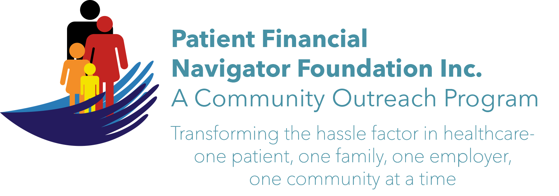 Article for HealthCare Buzz
Times News. April 2019
Article – 31
Glossary of Terms: Interoperability – Part 2
In part 1 of our Interoperability series, we began the education of understanding what the word means in healthcare and the challenges from the healthcare provider and patient’s perspective.
Definition: In health information technology, ‘interoperability’ means that information is able to be exchanged securely between different systems without special effort from the user, according to the Office of National Coordination of Health IT. However, in today’s electronic world, every healthcare provider has their own digital health record, along with their unique billing system.

As consumers are focusing on convenience, having rapid access to complete medical record, payment history, prescriptions, testing results from each individual healthcare provider in one connected network is a goal of interoperability. To better understand the challenge the healthcare industry -and ultimately each customer is facing, let’s walk thru an example.
- Patient A had an ER visit in hospital 1. The hospital uses an electronic record thru software company X with security to protect both the electronic patient history as well as the actual software platform. Hospital 1 in your town has built secure access for any local providers – doctors, oxygen companies, home health companies, physical therapy – to see your patient history from the ER visit. Patient A followed up with their primary care provider as directed who uses a different software company Y. However, since the physician is not part of the Hospital 1’s network, your primary care provider did not have the ability to upload their unique visit. A return visit to the ER 5 days later will likely not have the notes from the primary care visit as they were not part of the electronic record or provider network.
- Patient A goes to see her daughter in another town. Unfortunately, the patient had a medical emergency. Hospital 2 has their own, secure record with a different software vendor, Z. All historical medical history is not known to Hospital 2 nor the ER providers. All ER visit notes will reside in Hospital 2’s electronic record, with no ability to connect electronically to Hospital 1 nor the primary care provider.
- The patient requests to have all the medical record history from both hospitals, all physician visits under one secure patient history/portal versus each one having their own, independent portals with individual results, passwords, access, etc. WOW! Sounds a bit complex for any patient to navigate their own health care journey – not to mention the primary care provider being unable to see their patient’s full medical history.

Exciting ‘baby steps’ in this expensive yet dynamic process: one state is working with all healthcare providers to build an “ER visit repository” for all providers to access, regardless of where the ER visit occurred. As the country continues to look for ways to allow full interoperability of all medical records -while keeping it secure – multiple companies are starting to develop application program interfaces/API. The goal of ‘1 stop with ongoing updating for all healthcare providers’ -with 1 access point for the patient – is still being explored. The journey has begun to find a way to enhance the patient experience through a fully integrated medical history. Stay tuned!

Homework assignment: Do an internet search for Medicare’s Blue Button 2.0 project. Another “wow”.

All historic articles & training material are available on the Foundation’s webpage: PFNFInc.com. Day Egusquiza is the President & Founder of the Patient Financial Navigator Foundation, Inc- an Idaho-based, Family Foundation. 208 423 9036 (Do you have a topic for Healthcare Buzz? Please share at daylee1@mindspring.com. THANKS!)

