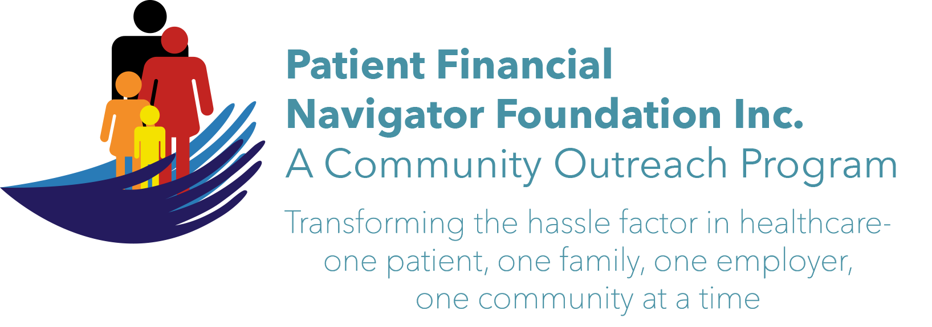 Article for HealthCare Buzz
Times News. March 2019
Article – 30
Glossary of Terms: Interoperability – Part 1
“Population health” “Value Based” “Chargemaster” “Portal” “Convergence” ‘Out of network” “Surprise bills” ‘AI” “Health Savings Accounts” “High deductible plans” “Working after 65 = working aged”. Any idea what these and many other healthcare ‘terms’ mean? Unfortunately, we are all a bit guilty of speaking in ‘our language’ assuming the audience/communities understand. It is very difficult to become the engaged patient if we don’t understand the basic concepts /words– some new, some old - that are being used within the conversation.
Healthcare Buzz will be providing operational, patient-focused education on these terms and more with a goal of reducing the stress factor thru easy to follow education. (Yes, healthcare can be complex, but it is teachable when we ‘become the patient.’ ) We will do this thru a new section: “Glossary of Terms.”
We will kick off this new series with a great concept: Interoperability.

Definition: “Interoperability is a characteristic of a product or systems, whose interfaces are completely understood, to work with other products or systems, at present or in the future, in either implementation or access, without any restrictions. Task of building coherent services for users when the individual components are technically different and managed by different groups…to allow for information exchange.” (Wikipedia) WOW! That is a bit much but here is the short version:
In most healthcare settings – A) Different doctors use their own/different electronic record documentation systems. B) Different hospitals use their own/different electronic record documentation systems. C) Home Health, Hospice, Durable medical equipment/DME, Oxygen companies, Pharmacies, & Skilled nursing facilities = all use their own/different electronic record systems.
Challenge: We all want our electronic medical history to be safe and secure from hacking or accidently sharing thru digital access. How does each healthcare provider build ‘firewalls/security’ and yet allow all healthcare providers to a) have access PLUS b) post their individual updates -using their own, unique/different electronic record and electronic access?
And what about the patients who want to ‘see’ their electronic records – all under one access, one interoperability format? What if we, the patients, want it on our smart watches or phones or tablets or laptops? How can that happen and have all our electronic information safe on our own devices?

In Part 2, we will walk thru some federal/Medicare upcoming mandates while we walk thru real examples. The digital record holds excellent patient-specific historical and current information for all healthcare providers to ‘see – but how?

All historic articles & training material are available on the Foundation’s webpage: PFNFInc.com. Day Egusquiza is the President & Founder of the Patient Financial Navigator Foundation, Inc- an Idaho-based, Family Foundation. 208 423 9036 (Do you have a topic for Healthcare Buzz? Please share at daylee1@mindspring.com. THANKS!)

