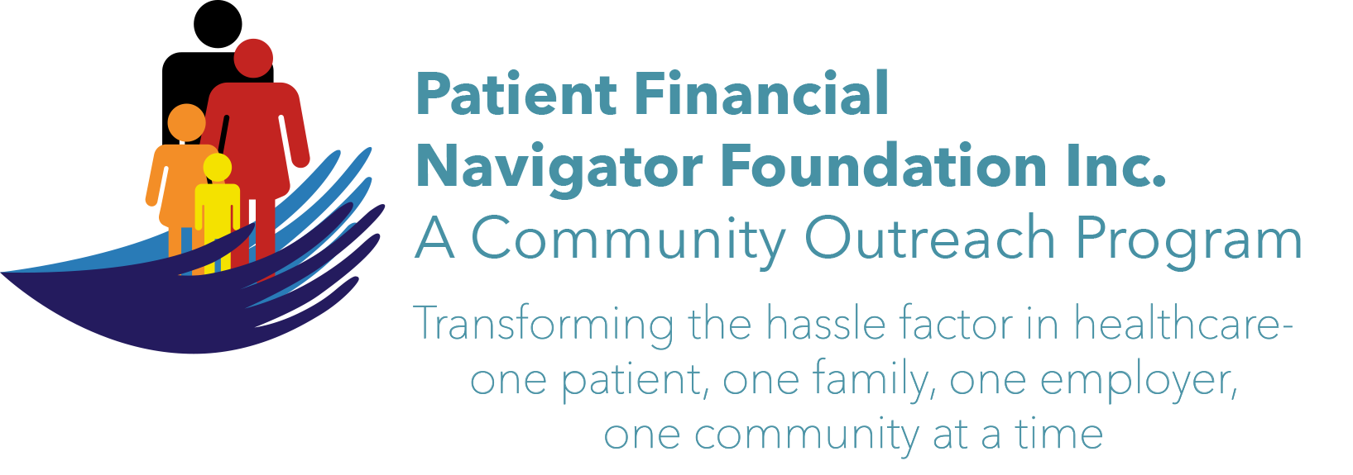 Article for HealthCare Buzz
Times News. May 2018
Article – 15
Turning 65: Impact of Loneliness
Shawna Wasko, PI/Contract Manager with the Office on Aging/OOA at CSI, does extensive outreach thru education at the Patient Financial Navigator Foundation Boot Camps and thru OOA sponsored training.
She shared some interesting statistics at the Feb boot camp:
Currently widowed women outnumber widowed men 4-1. In 1980, it was 6-1.
Widowed women are the poorest people in the US with studies showing the same statistic in every nation.
Men are at risk for death if they re-marry too soon. The Holmes Stress Chart shows that being widowed is the most stressful event in a person’s life. If men re-marry in a year after becoming a widow, it raises their score considerably. Men are highly effected by stressful events -including re-marrying too soon.
Shawna further shared that many re-marry due to loneliness which also increases their risk for scams. Many studies show that isolated and lonely seniors have a higher risk of becoming victims of scams. (Think – relationship scams.) Loneliness also raises the risk of a senior to develop Alzheimers. Other studies show that seniors who stay actively involved – like Sr Centers & Volunteering – have a much-reduced risk of becoming a victim.
There are many opportunities to stay involved in the community. Look at the community announcements in the paper, on social media, your religious group, local pet organizations, schools, the hospital, not-for-profit groups, grandparents support groups, to name just a few. Many groups are looking for a loving volunteer. Reach out as they would love to have you join them while staying active and healthy!

Join us! “2nd 2018 Medicare 101, Social Security Benefits and Assistance for Seniors Boot Camp” – Sat, June 9th. 8:30 am – 12:30 pm FREE. CSI Fine Arts. No pre-registration is required. Call Day at 423 9036 for more information. All articles & training material are available on the Foundation’s webpage: PFNFInc.com. Day Egusquiza is the President & Founder of the Patient Financial Navigator Foundation, Inc- an Idaho-based, Family Foundation.

