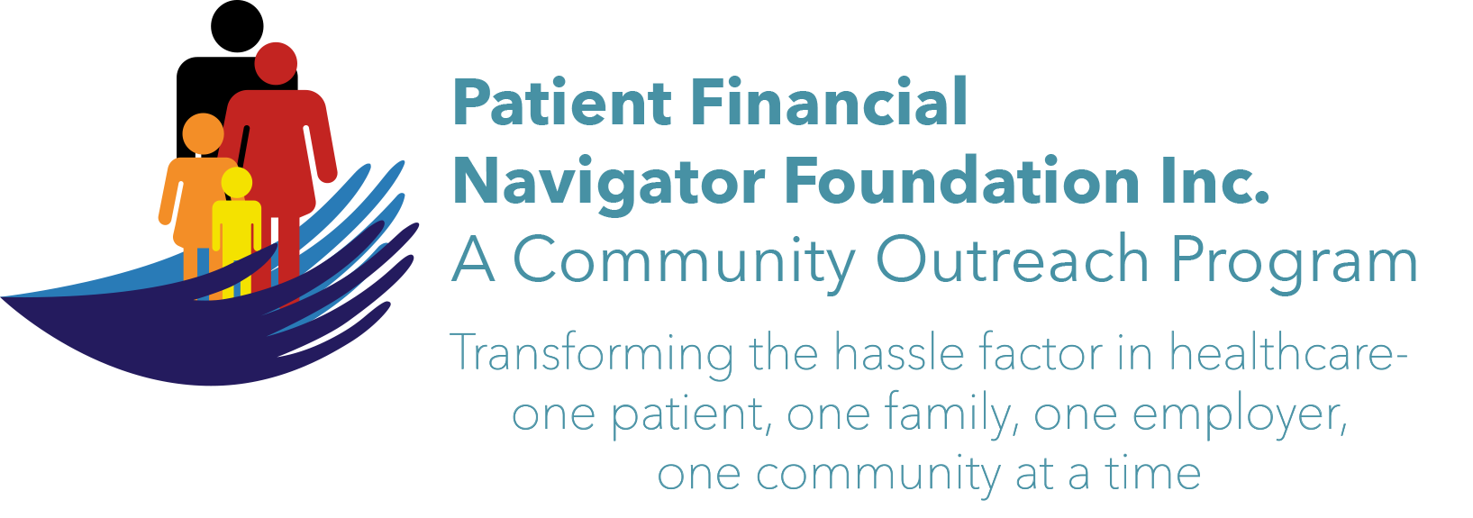 Article for HealthCare Buzz
Times News. April 2018
Article – 14
Turning 65: Medicare Advantage & Out of Network
In 2003, Medicare Advantage/Part C began to be sold to Medicare beneficiaries. Medicare Advantage/MA plans have enrolled approx 17 million participants. The MA plans are sold by private insurance plans which must include traditional Medicare benefits but can add additional services -such as a gym membership. The insurance plans approve healthcare services with the physicians and hospitals seeking prior authorization when healthcare is needed.

Just as with commercial insurance, the MA insurance plans are contracted with healthcare providers where the beneficiaries must go for care or pay the out of network penalty. Traveling to see family while having ongoing care -such as physical therapy, lab work, and other non-emergent -runs the risk of being out of network and paying higher out of network costs. Emergency care is always covered by the MA plans. However, it is important to discuss with the MA/private insurance plan when leaving the area for an extended of time/snow bird and discuss ‘in-network providers’ in the new location. There is a significant risk that non-emergent services will result in a high out of pocket expense for the patient as no providers may be in-network outside the primary residence. Be sure to review your travel plans, ongoing care concerns and other questions with an insurance agent prior to purchasing a MA plan. No hidden surprises.

Join us! “2nd 2018 Medicare 101, Social Security Benefits and Assistance for Seniors Boot Camp” – Sat, June 9th. 8:30 am – 12:30 pm FREE. CSI Fine Arts. No pre-registration is required. Call Day at 423 9036 for more information. All articles & training material are available on the Foundation’s webpage: PFNFInc.com. Day Egusquiza is the President & Founder of the Patient Financial Navigator Foundation, Inc- an Idaho-based, Family Foundation.

