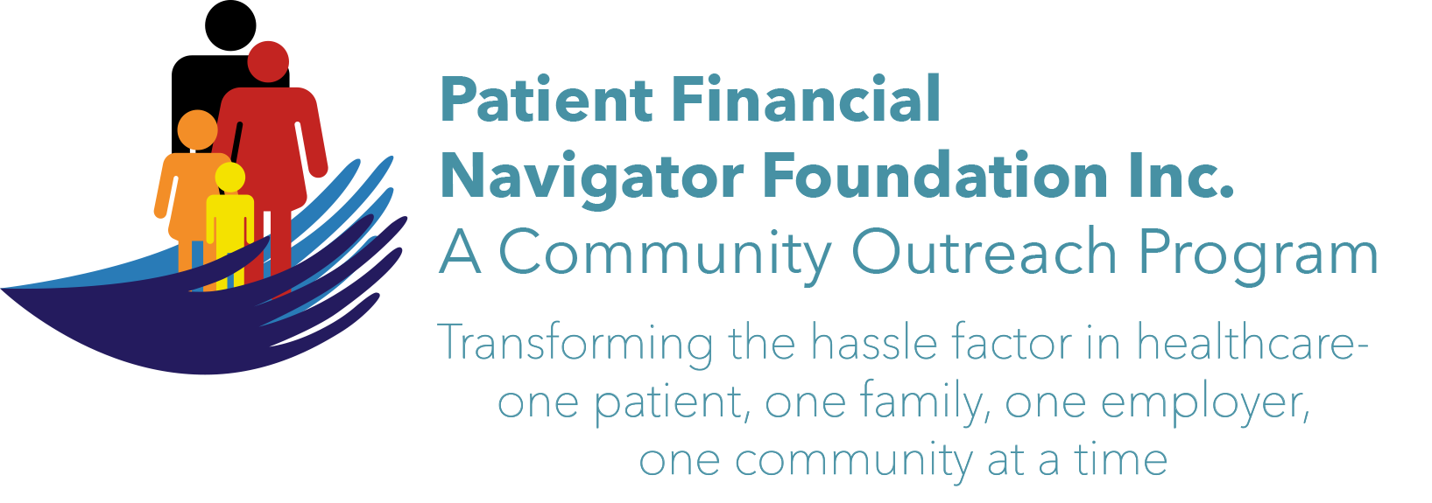 Article for HealthCare Buzz
Times News. Nov 2018
Article – 21
Turning 65: More Scams Keep Coming
Earlier this year, we presented a three-part series on Scams -including feedback from the Office on Aging/CSI and examples from the Federal Trade Commission/FTC. We provided guidance on how to prevent the scam from happening. We continue to receive update “Alerts” from the FTC plus local news alerts and ongoing phone and electronic attempts to hack into our electronic systems by ‘accepting’ and opening email attachments, replying to phone solicitation and fear tactics. Unfortunately, we all need to stay diligent as the scams continue to become more sophisticated, it is important to protect yourself. Here are multiple new scams that are coming thru email.
Note: Many of these are scams that came to my email. Lessons learned and how to spot scammers attempting to get access to your electronic devices are included below.

Email scams. Take a look at the some of the many recent email examples.
- EFax. “Fax Message- you have received a 6-page fax at 09-23-2018 at 08:37:55 GMT. Your personal reference number is … A ‘GET FAX” red box is at the bottom of the email. Signed by : efax crew. “ Do not open any attachment or “box” until you a) read the efax email address: efax@timewareinc.com and b) were you expecting a fax?
- American Express. “Hello cardmember. We are pleased to inform you on a timely security report for your American Express profile. At the time of evaluating the report, we discovered issues on your profile. In view of this, Cardmember information needs to be updated and your mandatory effort is required. Take a moment and download complete this form.” Red Alert – this person doesn’t have American Express. Once you download, your computer now gives the scammer/hacker’s access. Look at the email address before doing anything: AmericanExpress@pearsoncmg.com. Never download or open attachments unless you know the person sending it. This looks legitimate but it isn’t. Sentence structure and mis-spelled words were present.
- AT&T. “Your cellular bill is all set to be viewed. Dear client, your personal monthly cellular invoice for your account is ready to view. Overall balance: $215.05. Please view your invoice here/download.”
Do you have AT&T? No. Look at the email address: att@serberet.com
- Apple Inc. “Apple ID was used to purchase from Apple Online Store on a laptop or computer that hadn’t previously been used with that ID. You may be getting this email if you reset your security password since your previous purchase. If you made this purchase, please disregard this email. It was only sent to notify you in case you didn’t make the purchase. Click on the link to see the invoice. If you did not make this purchase, we highly recommend that reset your password.” WOW! This is a new twist as now you are being directed to go to the link if you didn’t buy the item. Email: Apple@cybermesa.com. Now the hacker has your updated information plus any additional questions they may ask to help ‘reset your security.’ No purchase was made; no Apple ID was ever created.

Report all that are obvious attempts to access your electronic device as none of the four were legitimate. Tell the Federal Trade Commission/FTC. Electronically-ftc.gov/complaint or call them 1-877-FTC-HELP.
Sign up for free scam alerts from the FTC at FTC.gov/scams.

All historic articles & training material are available on the Foundation’s webpage: PFNFInc.com. Day Egusquiza is the President & Founder of the Patient Financial Navigator Foundation, Inc- an Idaho-based, Family Foundation.

