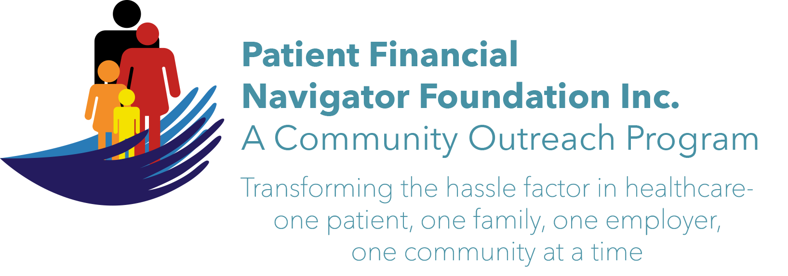 Article for HealthCare Buzz
Times News. April 2018
Article – 13
Turning 65: New Medicare Cards & New Challenges
It starts this month/April! New, safer Medicare cards will begin being mailed to the 58 Medicare million beneficiaries. The Medicare number will no longer be your social security number with an alpha character. It will now be a randomly generated 11-character Medicare Beneficiary Number (MBI) that looks something like- 1EG4-TE5-MK72. In planning for the change, be sure your address is correct. Use the Social Security webpage or call them if it is not accurate. They are rolled out randomly across the country with Idaho starting in June. Don’t be surprised if your spouse or your neighbor gets a new card and you don’t. It will happen; be patient.

When presenting for medical care, be sure to advise the healthcare provider of the new number. It will take some getting use to for everyone – including Traditional Medicare who processes all your claims in regional centers. We have yearly outpatient deductibles that may have started under the old number and must now be transferred to the new number. We have once every 60-day inpatient deductibles. If you were an inpatient in the 60 days under the old Medicare number, the historical information should be available with Medicare ‘seeing’ the history and not applying it a second time. If you have a Medicare Advantage/Part C plan, it will be impacted.
If you have a Medicare Supplemental Insurance plan- (86% of seniors pay for this insurance to cover the patient portion of Medicare claims)- it will be impacted as the insurance is tied to your Medicare number for payment purposes. There is a grace period where either the old number or new MBI can be used; but the sooner we begin using the new number, the better the historical information will be plus the increased security/less likely of scamming with the new number.

Challenge: As patients, it is important to be vigilant. Watch the Medicare statement /EOB you receive and keep them organized for later reference. As with any major change, there is an opportunity for confusion – from the patient, the healthcare provider and Medicare. The change is being made to protect from fraud- for all involved. Never give this new number to anyone but the healthcare provider. Don’t put the number in emails or any type of digital file. It could be easily intercepted.

Remember: Social Security number is for the social security monthly payments.
Medicare number is for the healthcare services. Now called the MBI number.

“If you spot a scam… tell the Federal Trade Commission/FTC.” To stop the many scams in the community, report them directly to FTC. Electronically-ftc.gov/complaint or call them 1-877-FTE-HELP. Another: AARP’s Fraud Watch Network at aarp.org/fraudwatchnetwork. Report it so others can learn and prevent it from happening to them.

(Join us! “2nd 2018 Medicare 101, Social Security Benefits and Assistance for Seniors Boot Camp” – Sat, June 9th. 8:30 am – 12:30 pm FREE. CSI Fine Arts. No pre-registration is required. Call Day at 423 9036 for more information. All articles & training material are available on the Foundation’s webpage: PFNFInc.com. Day Egusquiza is the President & Founder of the Patient Financial Navigator Foundation, Inc- an Idaho-based, Family Foundation.)

