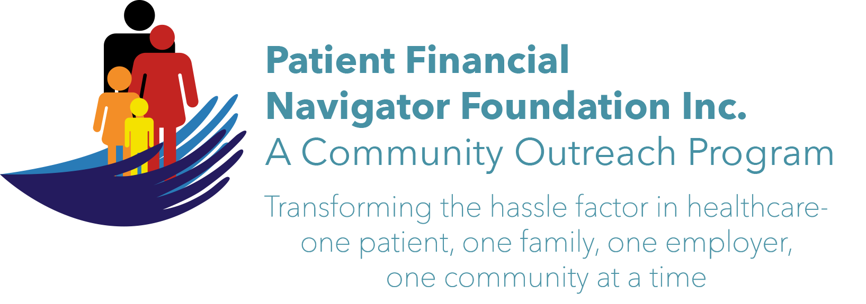 Article for HealthCare Buzz
Times News. Nov 2018
Article – 22
Turning 65: Opioid epidemic= Grandparents as Parents
“According to the Centers for Disease Control and Prevention (CDC), more than 72,000 Americans – or 200 people a day – died from a drug overdose in 2017, making it the worst year for drug overdoses in US history. Nearly two-thirds of these deaths were directly linked to opioids.” (Population Health News, Nov 2018)
During the recent “Preparing to Turn 65 Boot Camp” sponsored by the Patient Financial Navigator Foundation, Inc, Shawna Wasko, from the Office on Aging at CSI, shared some powerful statistics.
- Idaho is ranked number six in the nation for “Grandparent/relative as Parents/GAP.”
- The reason for this is the large amount of methamphetamine use in Idaho.
- GAP/grandparents can usually receive Temporary Assistance for Families in Need/TAFI.
- This grant is $309 a month – regardless of the number of children the grandparents are raising. Not $309 per child; but $309 as a flat fee.
- To apply for the TAFI grant, please call 211/Idaho Care Line/Department of Health & Welfare to start the process.

As is apparent, the financial strain on the grandparents can easily be overwhelming. The Office on Aging, with Shawna as the Facilitator, hosts a GAP support group which meets the second Monday of the month at the CSI Twin Falls Campus from 10:00-11:30 am. Many excellent community resources are shared with the ‘new’ parents who may not be financially or emotionally equipped to deal with the full-time responsibility of raising their grandchildren -who are also suffering with the loss of a parent or being taken from their home due to an unsafe environment. Foster care is still an option but having a relative care for them during the transition can help the children adjust better during an already traumatic situation. (Thanksgiving week reminds us yet again of the many ways we count our blessings. Day)

If you would like more information about the GAP support group, please contact Shawna Wasko at 208-736-2122. swasko@csi.edu

All historic articles & training material are available on the Foundation’s webpage: PFNFInc.com. Day Egusquiza is the President & Founder of the Patient Financial Navigator Foundation, Inc- an Idaho-based, Family Foundation. (Do you have a topic for Healthcare Buzz? Please share at daylee1@mindspring.com. THANKS!)

