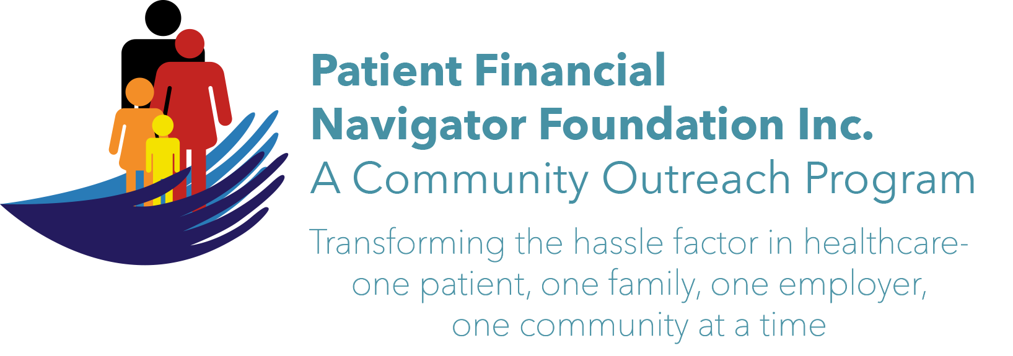 Article for HealthCare Buzz
Times News. March 2019
Article – 29
SCAMS: Phishing- Don’t take the bait
Unfortunately, the Federal Trade Commission/FTC continues to send Scam Alerts on a regular basis. (To receive your alerts directly, go to ftc.gov/subscribe to sign up.) What is Phishing? It is when someone uses fake emails or texts or calls to get you to share valuable personal information – like account numbers, social security numbers or login IDs and passwords. They can get access to your computer or network when you ‘click’ on the link as directed thru the scam email. Scammers use familiar company names or situations to pressure you – either thru ‘free’ or thru ‘fear /act or something bad will happen.”

Let’s review some Golden Rules for Email Scams:
- Always ready the email address completely.
- Never ‘click’ on any link associated with an email you don’t recognize. Never. This will allow them access to your computer or network.
- When in doubt, call the company directly. Never reply or follow any directions within the email.
- Report all potential scams directly to the FTC 888-382-1222.

Let’s review some real examples of email scams:
- Online FedEx Tracking. “Click on the tracking number below to see shipment. Tracking number 8395865451. “ SCAM as email address: “FedEx <fedex@signaturepoolsuk.com
- Earthlink Billing. “Your credit card company has declined our most recent request for recurring payment, resulting in past due balance. Click HERE and follow instructions.” SCAM as emails address: “Earthlink Billing < glenandmarcia@earthlink.net >
- Notifications@verizon.com “For the account below, Verizon invoices are now available to view online via the Verizon Enterprise Center. Master Acct. No. 3560545547976 To view, click on the link. Do not reply to this email.” SCAM as email address: <sidra.feroz@meezabair.com.pk>
- Cosco @Rewards. “Final notice: Costco $50 reward expiring soon.” SCAM as email address: <ilr97392daylee@dealessentials.biz”

Some of these are ‘fear’, others are ‘free’ – yet all are scams involve theft as their only goal.
Be diligent. Read all email addresses totally before proceeding. When in doubt, delete. Call the company and ask.
Report, report, report.
At the March 16th Boot Camp at CSI’s Fine Art’s building– we will have current scams along with more hints on protecting yourself from being a victim. Come and join us! 8:30-12:30 No cost, no pre-registration, all ages welcome. “Medicare 101, Social Security Benefits and Assistance for Seniors.”
All historic articles & training material are available on the Foundation’s webpage: PFNFInc.com. Day Egusquiza is the President & Founder of the Patient Financial Navigator Foundation, Inc- an Idaho-based, Family Foundation. 208 423 9036 (Do you have a topic for Healthcare Buzz? Please share at daylee1@mindspring.com. THANKS!)

