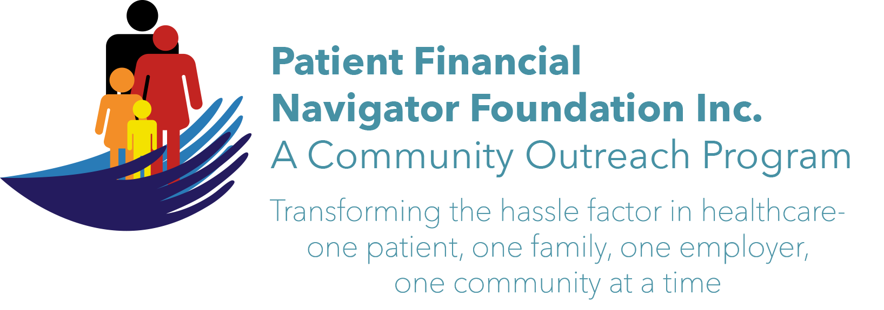 Article for HealthCare Buzz
Times News. July 2018
Article – 13
Turning 65: More Scams Keep Coming
Earlier this year, we presented a three-part series on Scams -including feedback from the Office on Aging/CSI and examples from the Federal Trade Commission/FTC. We provided guidance on how to prevent the scam from happening. Now we will outline more safety precautions as the scammers continue to become more sophisticated, it is important to stay diligent to protect yourself. Here are multiple new scams from the FTC plus some local ones that are coming thru email.

Email: always read who sent the email. Take a look at the some of the many recent email examples.
- Bank of America ‘security’ alert. “Your information may have been accessed by an unauthorized agent.” It had the BOA logo, included a Security and Privacy notice, BOA’s return address (so it looks very official.) What do they ask- “Please follow the below link to confirm your account information.”” RED FLAG alert… Now look at the email address – it is from ‘onlinebanking@ealerts.bankofa.com. (BOA did not send and asks anyone to contact them immediately: Abuse@bankofamerica.com)
- Sprint online bill payment. “Dear customer, your regular wireless bill on your account is now due. View your expenses and make a payment here.” RED FLAG alert. Never click the link..never! Email address: Sprint@sdcfl.com Not Sprint – Report it to mobileabuse@sprint.com . Person does not have Sprint service.
- IRS notices of delinquent payments. This one is especially ‘scary’ as multiple notices were sent. Each more threatening if the payment is not made. Indicates unpaid taxes from 201x, includes the tax form, and if you don’t call immediately, legal action will start. “Get billing information here” RED FLAG alert. Never go to the link. The IRS NEVER uses email; they only sent notices thru the postal service. Email address: Irs@lawrencetractor.com. Report these to phishing@irs.com
- Money offer if you coordinate with an individual who has just received a lot of money from out of country. Again, delete as rapidly as possible. Unfortunately, this can rapidly spiral into potential banking violations that the unknown helpful person may become involved in. Delete.

Be alert. Be aware. Check your credit report every year: Free report from AnnualCreditReport.com
Don’t give any financial information …ever. If you don’t know the number calling, don’t answer it. If it is an important call, they can leave a message or call back. If you spot a scam…Tell Someone. Then tell the Federal Trade Commission/FTC.” Tiana Hudson, Insurance Specialist, Office on Aging, CSI is an excellent source to discuss potential scams. (208 736 2122 x 2124) Electronically-ftc.gov/complaint or call them 1-877-FTC-HELP.
Sign up for free scam alerts from the FTC at FTC.gov/scams.

All historic articles & training material are available on the Foundation’s webpage: PFNFInc.com. Day Egusquiza is the President & Founder of the Patient Financial Navigator Foundation, Inc- an Idaho-based, Family Foundation.

