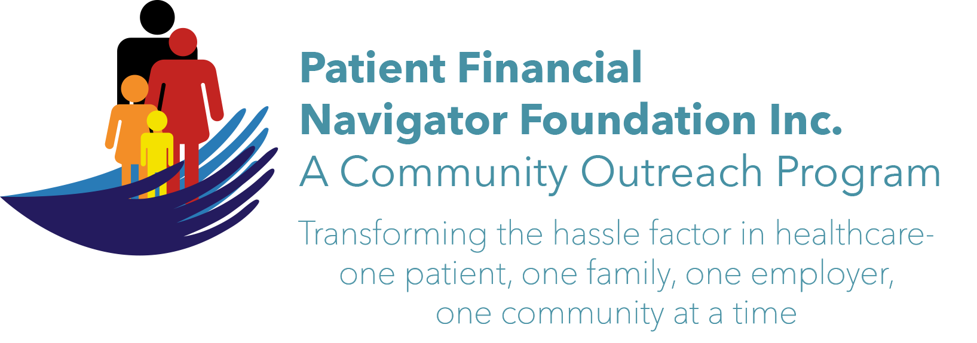 Article for HealthCare Buzz
Times News. Feb 2019
Article – 28
SCAMS: “Scam Likely”-Part 2
In Part 2 of our ‘Scam Likely’ series, we will review the efforts of the Federal Communication Commission/FCC (& Federal Trade Commission/FTC) to combat spam callers. Regardless of which wireless carrier you have, the unwanted calls don’t seem to stop. They can involve identify theft, scams for a large variety of financial attempts or just irritating calls. One of the main reasons service providers haven’t been able to stop all these seemingly random calls is that scam detection is inherently complex. Mimics of local area code and calling prefixes have become the ‘norm’ for many fraudsters’ calls.

In Nov, 2018, FCC Chairman Ajit Pai said in a statement that he demanded that the phone industry adopt a robust call authentication system to combat illegal caller ID spoofing (using your area code and first three -digit prefix to look like a local call) and launch no later than next year/2019.
Enter: STIR/SHAKEN What is STIR = Secure Telephone Identify Revisited -is a call certifying protocol.
What is SHAKEN = Signature -based Handling of Asserted Information using toKENs, verifies the caller’s right to use the subscriber’s phone number.

Each of the four wireless carriers - T-Mobile, AT&T, Sprint and Verizon – have been working to develop their own apps -most without a fee but some have more extensive services that include a monthly fee.
As reported by USA, Jan 23rd, the four major wireless carriers have adapted tools to provide the alert: “Scam Likely, Answer at your own risk.’ Ask about how your carrier is performing this function. It may say Scam Likely; it may be a stop sign; it may be another way but STOP… don’t answer any number you don’t know who it is. Messages can be left with calls returned as necessary.

Reach out to your wireless carrier (or their webpage) and ask about the free STIR/SHAKEN service you can access to protect you from the robo calls, potential scams and nuisance calls. They are all stating they are in ‘full on assault’ against unwanted calls. Find out! IT IS HERE!

ALERT: The Federal Trade Commission/FTC released that in 2018, $143 million was reported as lost due to ‘romance scams.’ This is the more than any other scam. Romance scams (think Valentine’s) prey on the lonely and vulnerable by offering to be a part of their lives but it will take money to come and visit or to reduce debts so they can have a relationship. REPORT -even if it is hard and may be embarrassing. FTC 888-382-1222.
At the March 16th Boot Camp at CSI’s Fine Art’s building– we will have current scams along with more hints on protecting yourself from being a victim. Come and join us! 8:30-12:30 No cost, no pre-registration, all ages welcome. “Medicare 101, Social Security Benefits and Assistance for Seniors.”
All historic articles & training material are available on the Foundation’s webpage: PFNFInc.com. Day Egusquiza is the President & Founder of the Patient Financial Navigator Foundation, Inc- an Idaho-based, Family Foundation. (Do you have a topic for Healthcare Buzz? Please share at daylee1@mindspring.com. THANKS!)

