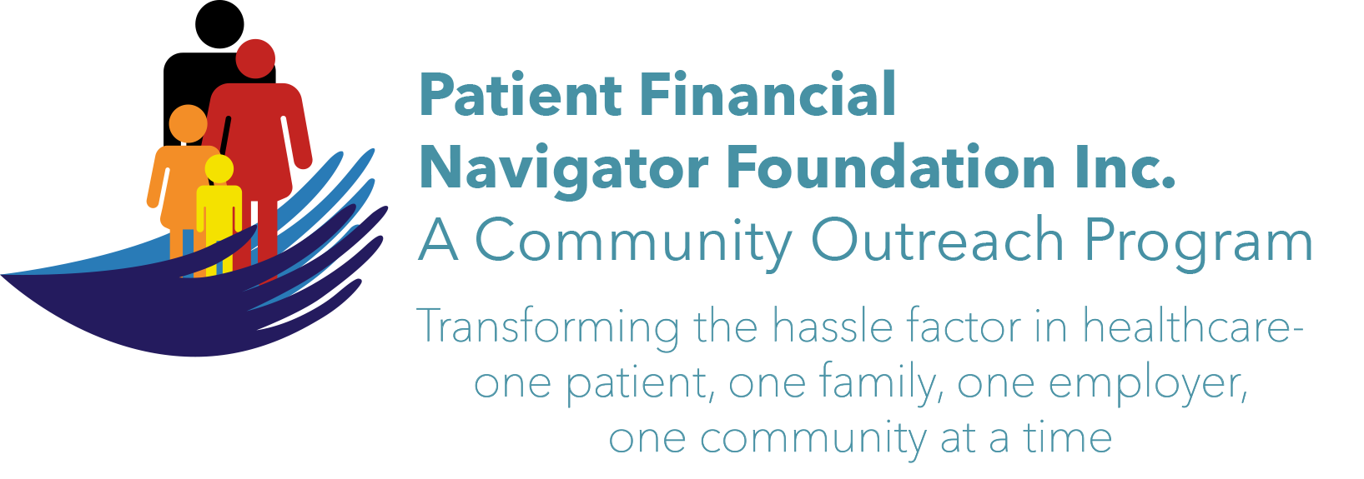 Article for HealthCare Buzz
Times News. April 2019
Article – 31
Glossary of Terms: Medicare’s Working Aged, Part 1
As 10,000 seniors turn 65 daily, the impact to Medicare beneficiaries using healthcare is becoming more critical with Part A/Inpatient Hospital and skilled nursing home care in jeopardy of becoming insolvent by approximately 2026. In an effort to address some of the expected shortfalls, in the early 1980s, Medicare made significant changes to help determine ‘who is the primary payer’ in multiple examples – such as accidents and continuing to work after 65 with commercial work-related insurance coverage. Medicare refers to this as “Medicare Secondary Payer/MSP” with the “Working Aged’ as one of the provisions. In this two-part series, we will provide education on the definition of the term and then provide insight in Part 2 into some decisions as you approach 65: Keep your commercial insurance or move to Medicare. (Part A has no monthly cost. Part B and Part D have monthly premiums.)
Let’s get started.

As you turn 65 and you are still working and have major medical commercial insurance through yourself or your spouse, here are the conditions that will impact who is primary when you have a healthcare bill.
- Beneficiary is age 65 or older and on Medicare due to age. (Remember, you can sign up for Part A with no cost while you are still working.)
- Insured person under the group health plan/GHP is the beneficiary or the spouse of the beneficiary.
- Group health plan means the employer employs 20 or more employees or the employer is part of a multi-employer plan in which at least one employer employees 20 or more.

Example of how this actually works: Beneficiary is 71 years old and on Medicare. He has Great West insurance from Ford as a retired Ford Motors auto worker. His spouse is age 63 and she works for Sprint. She covers the beneficiary with her Wellpoint insurance. The beneficiary has coverage under three policies: Medicare, Great West and Wellpoint. Medicare secondary payer guidelines require that Wellpoint pay before Medicare as Wellpoint coverage is active due to the employment status of the spouse and Sprint has more than 20 employees. Great West /retiree benefit from employer does not pay before Medicare because the beneficiary does not have current employment status with Ford. (Example courtesy of Medicare’s Working Aged educational material.)

Golden rule: If the beneficiary is retired, Medicare is primary, if there is no other spouse-related coverage. Once the spouse no longer has coverage or retires – the beneficiary’s Medicare benefit will become primary as the Ford retiree coverage is not due to ‘current employment status.’

Home work assignment: Do an internet search for ‘Medicare – Working Aged MSP” and continue your learning journey. Have fun!

All historic articles & training material are available on the Foundation’s webpage: PFNFInc.com. Day Egusquiza is the President & Founder of the Patient Financial Navigator Foundation, Inc- an Idaho-based, Family Foundation. 208 423 9036 (Do you have a topic for Healthcare Buzz? Please share at daylee1@mindspring.com. THANKS!)

