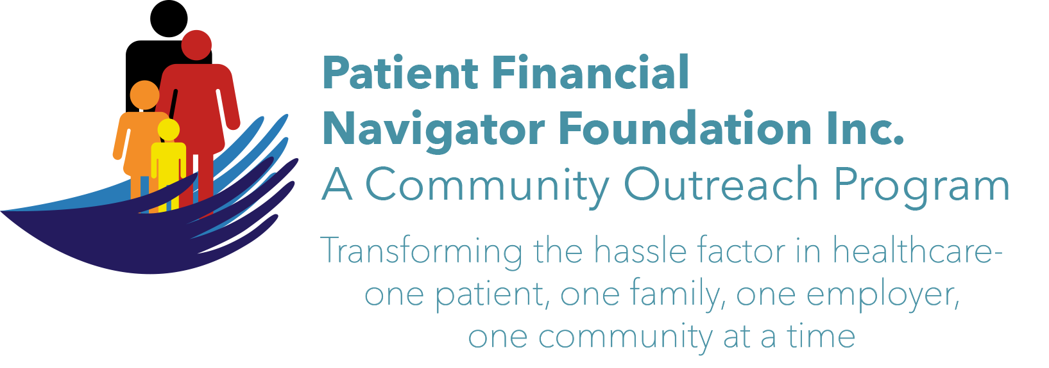 Article for HealthCare Buzz
Times News. May 20, 2017
Article – 2
What is a healthcare patient portal?

In a December, 2016 post by Kate Goodrich, MD, MHS, Director of the Center for Clinical Standards and Quality at Center for Medicare and Medicaid Services/also known as Medicare /CMS, wrote that patient engagement is designed to ‘strengthen person and family engagement as partners in care.“ Over the past five years, the healthcare industry has been moving to a more automated way to share patient information – beyond the walls of the hospital. The goal is to improve the patient experience by connecting physicians, hospitals and other care givers to have the complete patient history -including the patient having access to all their records, test results, provider notes and even electronic access for communication. It is exciting but can be a bit daunting for the patient who is uncomfortable with health ‘literacy’ and challenged with the ability to ‘access their portal.’ So what is a portal? It is an electronic history of the patient’s health record. The creation was part of the ACA/Obamacare and has grown to be a highly effective way to communicate between the providers and the patients.

BUT – with the many ‘hacking’ stories, there is hesitancy to use the portal. There are barriers -from not feeling ‘computer literate’ to fear of other people ‘seeing’ their private health care information to not knowing what to do when there is a note sent regarding a pending item within the portal. Significant safeguards are in place, so don’t be afraid to ask your healthcare provider about their security measures.

Concerning: As many as 41% of patients are discharged with test results still pending with 37% of the results actionable. “ United HealthCare Insurance Hospital Readmissions”, effective 10-1-16. Promoting Safe Hospital Discharges.

Do you know how to access your private, secure portal? Adverse patient outcomes, potential preventable re-admissions and other unfortunate negative patient care can result from not following up on any ‘portal’ notices while feeling comfortable accessing and reading your own history.

ACTION ITEMS:
- Healthcare providers should explore having a computer available in a semi-private area of the waiting room= “3 min” hands on education. The healthcare staff should offer to show anyone, as they wait, how to access their portal. Have a written, step by step, guide by the computer with staff available to walk thru ‘how to’ 1 on 1 with the patients. There is always a brochure in all healthcare areas on how to access the portal with reference numbers, but no one likes to feel ‘stupid’ and may not call.
- If a patient is uncomfortable– don’t be afraid to ASK! Don’t understand the words? – ASK! Unfortunately, with a high percentage of patient being leery with electronic access and with the move to more electronic usage – helpful hints will ensure follow up to actionable, important healthcare items. Fear of what information is in the electronic record can also be reduced through onsite education. It can be a great partnership.
- For more educational information, visit the webpage: PFNFInc.com

