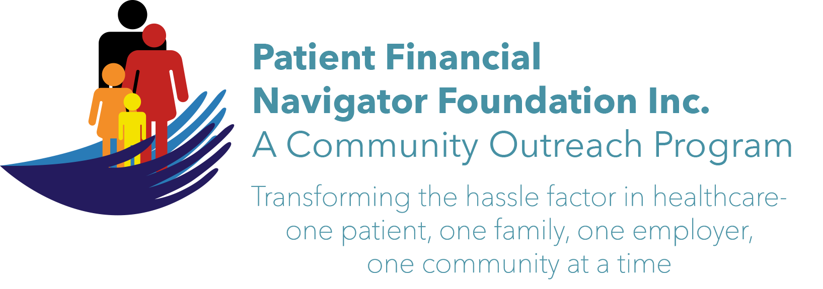 Article for HealthCare Buzz
Times News. June 2017
Article – 3
Turning 65: Initial Preventive Exam
The peak of the baby boomers – post World War II babies born between 1946 and 1964 – is hitting with approx 10,000 turning 65 daily. The ‘aging of America’ is well underway with 20% of the population over 65 by the year 2029. Added to the longevity of the current seniors – women live to 83; men to 80 – there is a need to adjust to an aging public and encourage a healthy lifestyle.

Part of the change for Medicare’s focus on ‘healthy’ was the creation of the “Initial Preventive Physician Examination/IPPE.” Medicare pays for one IPPE per beneficiary per lifetime for beneficiaries within the first 12 months of the effective date of the Medicare Part B (physician and outpatient services) coverage period. This is also called the “Welcome to Medicare Preventive Visit.” Your healthcare provider will do a medical and social history, review your mental health risk factors, your functional ability and level of safety in your current living environment, do a physical exam, and discuss end of life planning include advance directives which directs healthcare providers on your end of life choices. Finally, upon completion of the IPPE visit, counseling or additional referral for preventive services will be done.

Medicare does not cover routine physical examinations. The IPPE is the once in a lifetime covered physician visit that will have all patient coinsurance or deductible amounts waived. There will be no out of pocket cost to the newly turned 65 year-old patient.

ACTION ITEMS:
- Don’t wait! Contact your provider within 12 months of turning 65 and take advantage of this once per lifetime Initial Preventive Exam with no cost to the patient.
- Ask the important questions – listen well to the risks.
- If you did not get your IPPE/Wellness Exam in 2016 and you are still within the 12 -month period of your initial Part B/outpatient and doctor coverage – you can still get the visit at no cost.
- Don’t wait as the scope of the visit is extensive.
- Remember -this is a once in a lifetime benefit. It is not the Annual Wellness Visit/AWV. More on that next time.

Need more information? Ask your provider or his office as they are well aware of this great Medicare benefit. Or the Social Security office has the “Medicare and You 2017’ booklet. Another excellent teaching tool.

COMING: Patient Financial Navigator Foundation, Inc is hosting the 2nd 2017 Community Boot Camp on July 6th at no cost. “Medicare 101, Social Security Benefits and Assistance for Seniors” at CSI. Go to the webpage PFNFInc.com to learn more.

