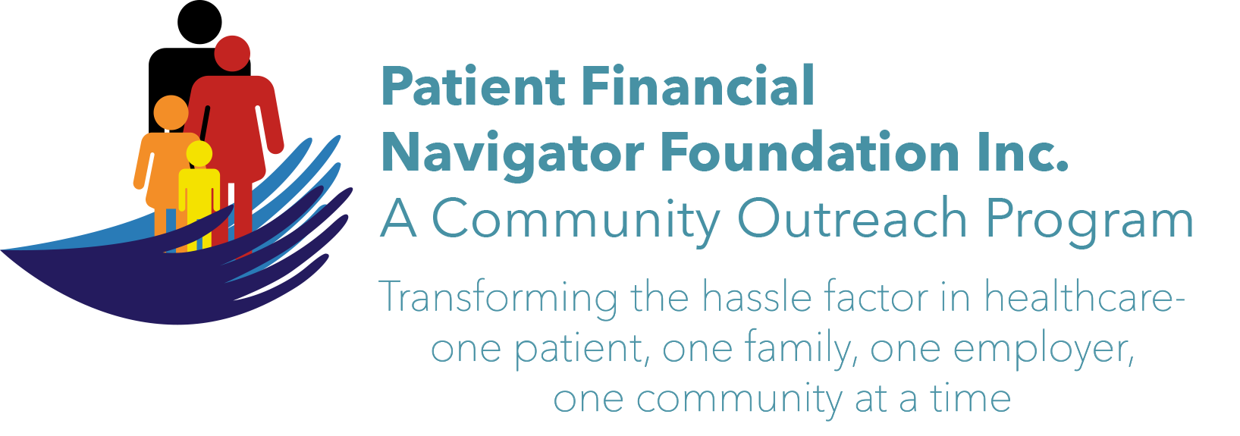 Article for HealthCare Buzz
Times News. Nov, 2017
Article – 8
Turning 65: Medicare Choices- It is that time of year
It is Fall Enrollment time for Medicare beneficiaries. Each year, between Oct 15 and Dec 7th, every Medicare beneficiary can elect to enroll in a Medicare Advantage/Part C/Managed Medicare or change Medicare Advantage plans or move back to Original Medicare. It takes patience to determine which option is best for you: Traditional/Original Medicare or Medicare Advantage. If you change coverage, your coverage starts January 1st.

In most cases, Fall Open Enrollment is the only time you can pick a new Medicare Advantage or Medicare Part D plan. If you have a Medicare Advantage plan, you can also choose to switch to Original Medicare. With this change, you must join a stand-alone Part D /Medicare drug coverage plan to avoid penalties plus evaluate Medigap/Medicare supplemental insurance plans for the co-payment and deductibles associated with the change to Original Medicare. *Remember – a Medigap plan cannot be purchased with a Medicare Advantage/MA plan to assist with the out of pocket costs associated with the MA plan.

Medicare Advantage/Part C must offer all the Original Medicare coverage items with the individual insurance plans allowed to add additional benefits. Each plan has its own unique pricing. Medicare Advantage plans are private insurance companies who have contracts with Medicare to provide Part A & Part B coverage with many also covering Part D/Prescription drug benefit which was added in 2006.

What if you are dissatisfied with your Medicare Advantage Plan? You can disenroll from that plan and join Original Medicare during the “Medicare Advantage Disenrollment Period/MADP”. The MADP is every year from Jan 1-Feb 14th.

Great resources to help with choices:
Call Medicare 1-800-Medicare Ask about ‘MyMedicare’- a great guide; Medicare Advantage options, other questions.
Using Medicare’s webpage- www.medicare.gov – check out many resources including stand-alone prescription drug plan (PDP) plus frequently asked questions.
State Health Insurance Assistance Program plus reach out to the local Office on Aging for additional support.
Local insurance agents who can help walk thru the options – your current prescription drugs, retirement plans, plus all Part C/Medicare Advantage plans in the area.

Now is the time to do a review of your prescription drugs you are taking – check your Part D tiers of coverage as each drug is attached to a tier that will be impacted by your monthly premiums. Discuss travel plans -as out of network penalties will apply if non-emergent care is done outside the insurance company’s network.

Is healthcare complicated? The payment system is different for each insurance plan, Medicaid/per state and Traditional Medicare vs Managed Medicare/Medicare Advantage. Learn more about all the areas of impact thru the 1st 2018 Patient Financial Navigator Community Boot Camp: “Medicare 101, Social Security Benefits and Assistance for Seniors” Sat, Feb 3rd CSI Fine Arts. 8:30 am-12:30 PM. No Cost! No pre-registration is required! Let us help reduce the hassle factor thru education. (Day Egusquiza is the President & Founder of the Patient Financial Navigator Foundation, Inc- an Idaho-based, Family Foundation.)

