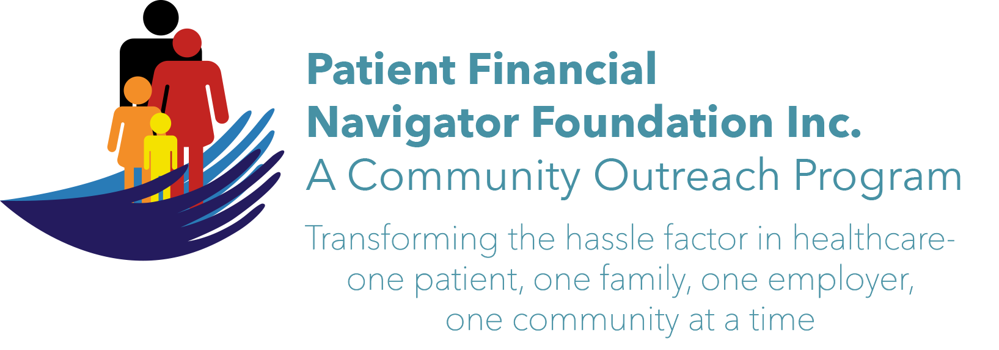 Article for HealthCare Buzz
Times News. Sept 20, 2017
Article – 6
Turning 65: Working past 65? Medicare as Secondary Payer
The peak of the baby boomers – post World War II babies born between 1946 and 1964 – is hitting with approx 10,000 turning 65 daily. The ‘aging of America’ is well underway with 20% of the population over 65 by the year 2029. However, as reported by the Associated Press:
“More Americans age 65& over are still punching the time clock and the last time the percentage was this high was when John F Kennedy was in the White House, 1962. Last month, 19% of Americans age 65 and over were still working, according to government data published May 2017. That’s the highest rate since 1962 and it caps a long trend higher since the figure bottomed out at 10% in 1985.”

With this large percentage of baby boomers working past age 65, it is important to understand the Medicare Secondary Payer/MSP rules. MSP is the term generally used when the Medicare program does not have primary
payment responsibility- that is, when another entity/insurance has the responsibility for paying before Medicare. In 1980, Congress passed legislation that made Medicare the secondary payer to certain primary plans in an effort to shift costs from Medicare to the appropriate private sources of payment. The category of ‘Working Aged” -those who work for an Employer Group Health Plan (GHP) -with at least 20 employees have specific rules as outlined in CMS.gov.
Individual is age 65 or older, is covered by a GHP through current employer or spouse’s current employment and the employer has 20 employees = GHP pays primary, Medicare pays secondary.

When turning 65, it is important to explore signing up for Medicare Part A at no cost even if you are keeping your employer’s health plan coverage. During the registration process when receiving healthcare services, the provider will question – are you employed? This information is important to ensure the correct payer is billed primary while protecting the Medicare Trust Fund (like a saving’s account that pays healthcare bills) by ensuring that group health insurance plans pay correctly – then Medicare.

Is healthcare complicated? The payment system is different for each insurance plan, Medicaid/per state and Traditional Medicare vs Managed Medicare/Medicare Advantage. Learn more about all the areas of impact thru the Patient Financial Navigator Community Boot Camp: “Turning 65” Sat, Oct 28th CSI Fine Arts. 8:30 am-1:30 PM. No Cost! No registration is required! Let us help reduce the hassle factor thru education. (Day Egusquiza is the President & Founder of the Patient Financial Navigator Foundation, Inc.)

