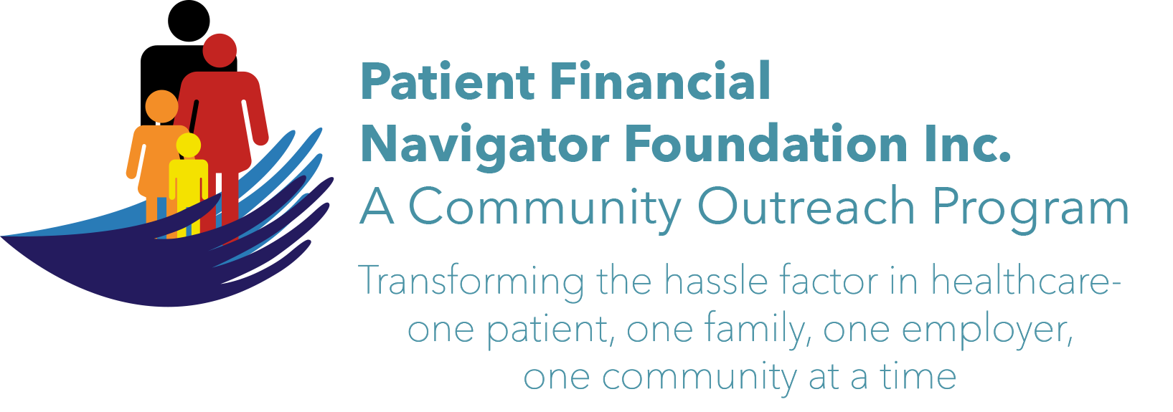 Article for HealthCare Buzz
Times News. Aug 30, 2018
Article – 16
Turning 65: New Medicare Cards/New Numbers
New Medicare cards are coming. Medicare has announced that Idaho is in wave 6 which will begin after Aug, 2018.
Other parts of the country already have their new Medicare Beneficiary Identifier (MBI) number issued. Medicare is required to replace the Social Security numbers with the new 11 digit – both alpha and numeric numbers – by April 2019. Other parts of the country – waves 1-3- are completed. Wave 4-5 are now underway. So don’t be alarmed if a friend or relative in Alaska or Delaware or Illinois or parts of the country already have theirs. They are included in the 1st three waves. Idaho is part of wave 6 which includes some of our neighboring states – like Utah, Nevada, Washington, Wyoming.

If you are new to Medicare – you may already have your new card as they are being issued as you sign up – regardless of where you live.

If you have questions about the new cards – or if you have any doubt that your address is accurate – please immediately go to MyMedicare.gov and see if a new card has been mailed and you did not receive it-if you have a friend or family member in waves 1-5. Also call 1-800-Medicare (1-800-633-4227) and ensure everything is correct. MySocialSecurity.gov is another site.
Double check all addresses so your card is received correctly. (You will need to set up an account.)
Once you receive the new card, begin using it. However, either card can be used through Dec 31, 2019.
The new MBI number was created to help protect the social security numbers from possible fraud. Safeguard the new number.

With a mid-calendar year change, there is a chance that the financial history under the old Medicare number may not cross correctly to the new Medicare number. Medicare expects it to be ‘transparent’ and simple but be stewards of your yearly deductible and ensure it is only applied once.

EXCITING! The 3rd 2018 Medicare 101 Boot camp will be Sat, Nov 4th at CSI from 8:30-12:30 pm. It will focus on all elements of “Turning 65”. Save the date! No pre-registration. No cost. Call 208 423 9036 with questions. All historic articles & training material are available on the Foundation’s webpage: PFNFInc.com. Day Egusquiza is the President & Founder of the Patient Financial Navigator Foundation, Inc- an Idaho-based, Family Foundation.

