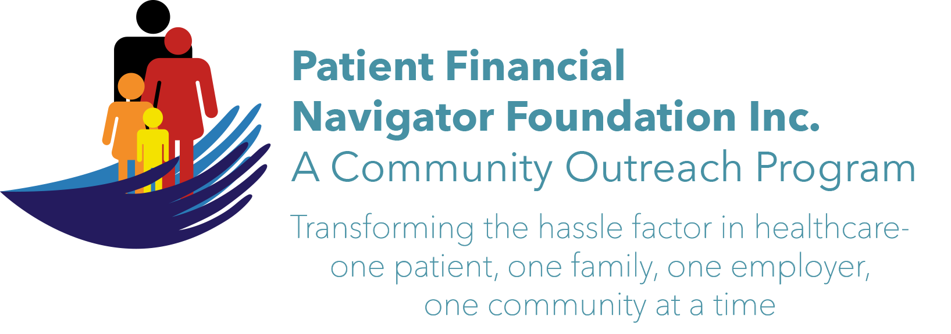 Article for HealthCare Buzz
Times News. Sept 13, 2018
Article – 17
Turning 65: Alzheimer’s Disease
As the Baby Boomer’s continue to age, early diagnosis of Alzheimer’s provides a number of important benefits to the diagnosed individuals, their caregivers and loved ones, as well as society as a whole. In the Alz.Org/Facts information webpage, there is a special report regarding the development of biomarkers for Alzheimer’s disease that is making it possible to detect Alzheimer’s disease and provide an accurate diagnosis earlier than at any other time in history. In addition to providing significant medical, emotional and social benefits and facilitating participation in important clinical trials, early diagnosis enables individuals to prepare legal, financial and end-of-life while they are still cognitively able to make decisions and share their wishes.

Early diagnosis, even without biomarker evidence for a specific underlying cause, will also yield significant cost savings in medical and long-term care for both the US government and diagnosed individuals. Among all Americans alive today, if those who will get Alzheimer’s disease were diagnosed in the mild cognitive impairments (MCI) stage – before dementia – it would collectively save $7 trillion to $7.9 trillion in health and long-term care costs.

Facts and Figures:
Alzheimer’s disease is the 6th leading cause of death in the US
Between 2000 – 2015 deaths from heart disease have decreased 11% while deaths from Alzheimer’s have increased 123%.
1 in 3 seniors dies from Alzheimer’s or another dementia which kills more than breast cancer and prostate cancer combined.
In 2018, Alzheimer’s and other dementias will cost the nation $277 billion by 2050. These costs could rise as high as $1.1 trillion.
5.7 million Americans are living with Alzheimer’s. By 2050, this number is projected to rise to nearly 14 million.
Every 65 seconds someone in the United States develops the disease.

EXCITING! The 3rd 2018 Medicare 101 Boot camp will be Sat, Nov 3rd at CSI from 8:30-1:00 pm. It will focus on all elements of “Turning 65”. Save the date! No pre-registration. No cost. Call 208 423 9036 with questions. All historic articles & training material are available on the Foundation’s webpage: PFNFInc.com. Day Egusquiza is the President & Founder of the Patient Financial Navigator Foundation, Inc- an Idaho-based, Family Foundation.

