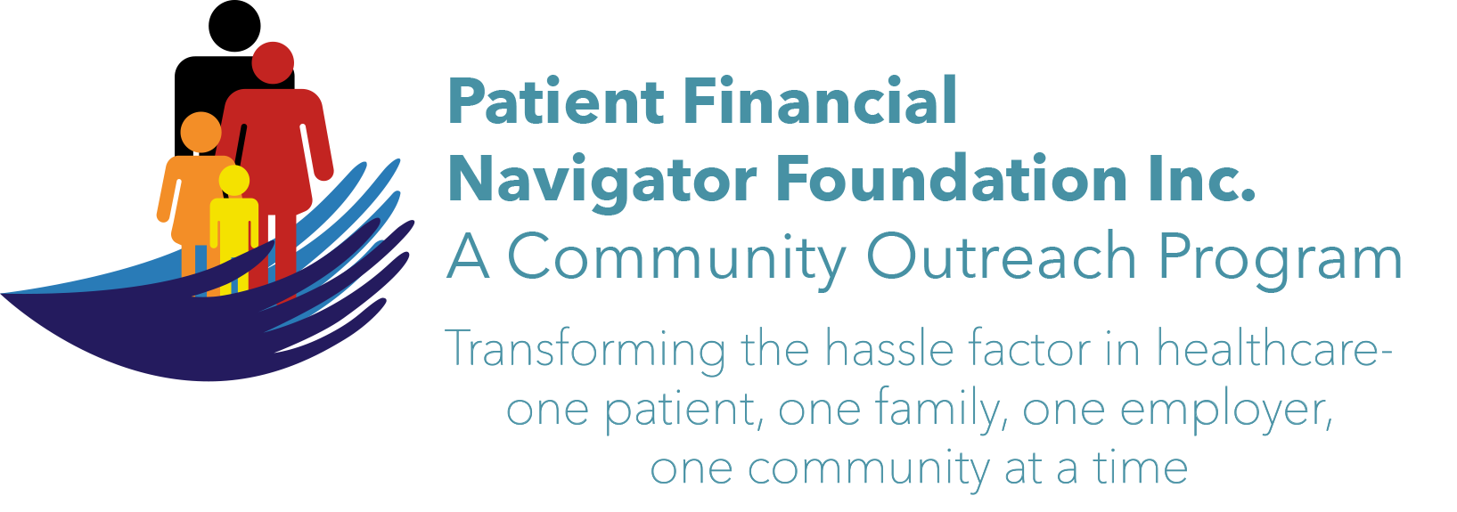 Article for HealthCare Buzz
Times News. Sept 29, 2018
Article – 18
Turning 65: Alzheimer’s & Sleep Deprivation -Part 1
In a recent article by Raj Sandou, Assisted Living Newsletter, with a reference to the National Institute of Health- Sleep Deprivation Increases Alzheimer’s Protein, he discusses how the relationship between poor sleep hygiene and poor mental health care are strongly interrelated. A 2018 research study shows that sleep deprivation can lead to an increased risk of Alzheimer’s disease. Findings from this study underline the importance of promoting better sleep.

Beta-amyloid is a metabolic waste product that is produced in our bodies. This product can cause Alzheimer’s disease. B-amyloid is found in the fluid between brain cells (neurons.) When b-amyloid clump together, they form amyloid plaques which can hinder communication between neurons. A greater amount of B-amyloid in the brain would result in a higher number of amyloid plaques and worse communication between neurons.

Researchers scanned participants’ brains after getting a full night’s rest and after a night of sleep deprivation. Through comparison of the scans, researchers found a 5% difference in the amount of B-amyloid in participants’ brains: with the increase being in those who were sleep deprived. Thus, sleep deprivation translates into an increased risk of Alzheimer’s disease.

Promoting good sleep hygiene can support improved physical and mental health and also reduce the risk of Alzheimer’s disease. Generally, all adults need about the same amount of sleep 7-9 hours each night. Older adults tend to go to sleep and get up earlier than younger adults.

We will visit some of the reasons for poor sleep in Part 2.
(Thanks to the Office on Aging, CSI, for forwarding this great article to my attention.)

EXCITING! The 3rd 2018 Medicare 101 Boot camp will be Sat, Nov 3rd at CSI from 8:30-1:00 pm. It will focus on all elements of “Preparing to Turn 65”. Save the date! No pre-registration. No cost. All ages welcome. Call 208 423 9036 with questions. All historic articles & training material are available on the Foundation’s webpage: PFNFInc.com. Day Egusquiza is the President & Founder of the Patient Financial Navigator Foundation, Inc- an Idaho-based, Family Foundation.

