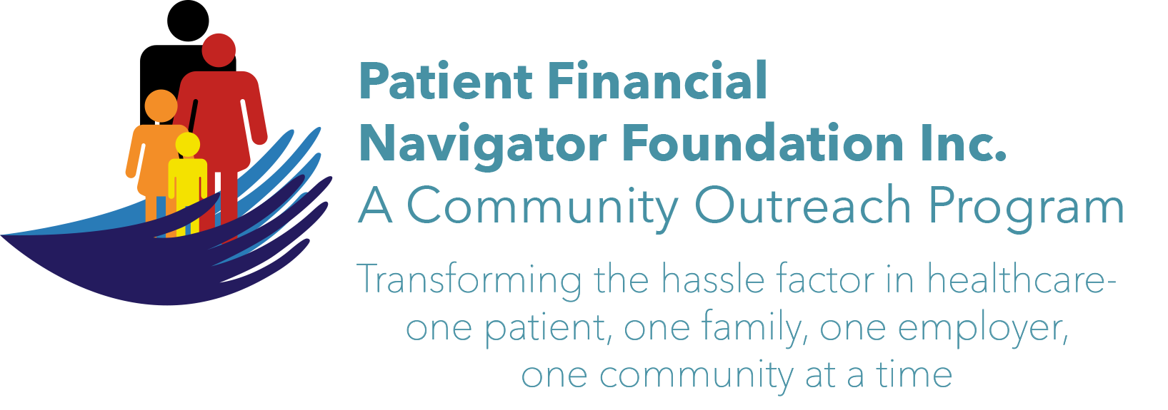 Article for HealthCare Buzz
Times News. Oct 10, 2018
Article – 19
Turning 65: Alzheimer’s & Sleep Deprivation -Part 2
In part 1 of this 2-part series, a recent article by Raj Sandou, Assisted Living Newsletter, with a reference to the National Institute of Health- Sleep Deprivation Increases Alzheimer’s Protein, he discusses how the relationship between poor sleep hygiene and poor mental health care are strongly interrelated. A 2018 research study shows that sleep deprivation can lead to an increased risk of Alzheimer’s disease.

Some of the reasons for poor sleep in older adults are feeling sick, being in pain, and medication side effects. The follow are some ideas to consider when trying to promote good sleep hygiene:
- Address any signs or symptoms of illness, discomfort, pain, etc.
- Monitor medications for side effects.
- Ensure adequate exposure to natural light during daytime.
- Exercise regularly.
- Limit daytime naps to 30 mins.
- Avoid stimulants such as caffeine or nicotine close to bedtime.
- Establish a regular, relaxing, bedtime routine.
- Make sure that the sleep environment is pleasant.

Alzheimer’s Facts (Alzheimer’s Association)
- Estimated 5.7million Americans of all ages are living with Alzheimer’s dementia in 2018.
- One in ten age 65 are older (10%) has Alzheimer’s dementia.
- Almost two-thirds of Americans with Alzheimer’s are women.
- Older African-American are about twice as likely to have Alzheimer’s or other dementias as older whites.
- Hispanics are about one and one-half times as likely to have Alzheimer’s or other dementias as older whites.
- Today, someone in the United States develops Alzheimer’s every 65 seconds. By mid-century, someone in the United States will develop the disease every 33 seconds.

EXCITING! The 3rd 2018 Medicare 101 Boot camp will be Sat, Nov 3rd at CSI from 8:30-1:00 pm. It will focus on all elements of “Preparing to Turn 65”. Save the date! No pre-registration. No cost. All ages welcome. Call 208 423 9036 with questions. All historic articles & training material are available on the Foundation’s webpage: PFNFInc.com. Day Egusquiza is the President & Founder of the Patient Financial Navigator Foundation, Inc- an Idaho-based, Family Foundation.

