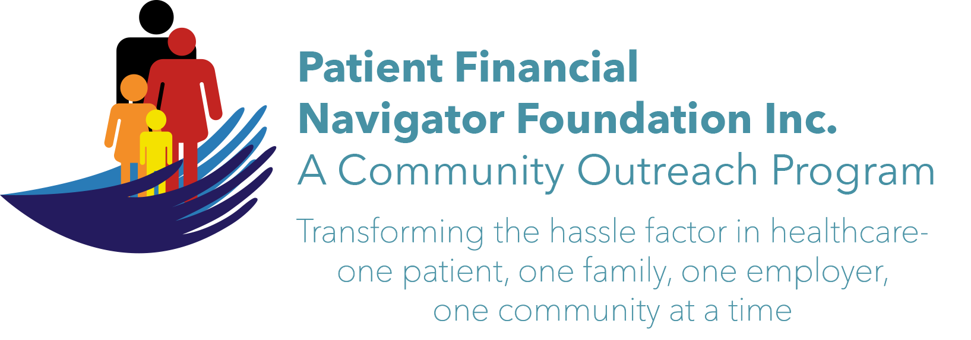 Article for HealthCare Buzz
Times News. Aug 2018
Article – 14
Turning 65: The Work of Being A Patient, Part 1

No one asks to get ill. No one asks to have their life disrupted by an unexpected illness. No one can anticipate the cost of the illness – both for the immediate treatment and the potential long-term impact to our health. Very few know what to expect from their insurance or their high deductible plan and their out of pocket expenses. Healthcare is very personal and the mental health impact is as important as the physical impact. In a recent interview with Mark Stevens, human resource leader, coach and author of “The Square & Triangle”, he outlined some of the challenges we all face when becoming a patient. In the first of a two-part series, Mark shares some life lessons and hints for ‘being a patient.”.

“Life is learned thru analogy. Or so it seems. We all build our collective consciousness of things through the comparison of those things. “Fly like an eagle.” “Life is like a box of chocolate.” The point is that often what we learn in one area of our life can help another part of it. Your journey through healthcare is no different. Today’s modern world of medicine is more complicated than ever. From drugs to diagnoses, to the complexity of getting in to see a doctor, to interpreting the bill. Being a patient has never been harder-despite the modern world’s access to information. The problem is fundamentally this; if you want better health and better healthcare, it is your responsibility to go get it.

“Frankly, that doesn’t seem fair. Seems like the doctor should do the work, the nurses should make the phone calls, and the insurance company should pay the bill. But not anymore (as if it was ever this way.) The reality is that if you want to be a great patient, YOU need to take control. Health systems may say they want to be your partner, but very few really are. That’s not blame – it’s reality. They run too lean with too many ‘ priorities’.”

“Here comes the analogy. Isn’t it this way at work? When we ‘assume’ our employer is going to do everything for us, we usually end up disappointed. To be an engaged employee, we need to care about what we do, make sure our boss knows what we need, then go do it! It’s not enough to blame everyone for our job, then assume that things are magically get better. The same skills and attitudes it takes to be good at our work can help us be more productive patients.” Learn how in Part 2 of this series.

All historic articles & training material are available on the Foundation’s webpage: PFNFInc.com. Day Egusquiza is the President & Founder of the Patient Financial Navigator Foundation, Inc- an Idaho-based, Family Foundation. Mark Stevens resides in Twin Falls.

