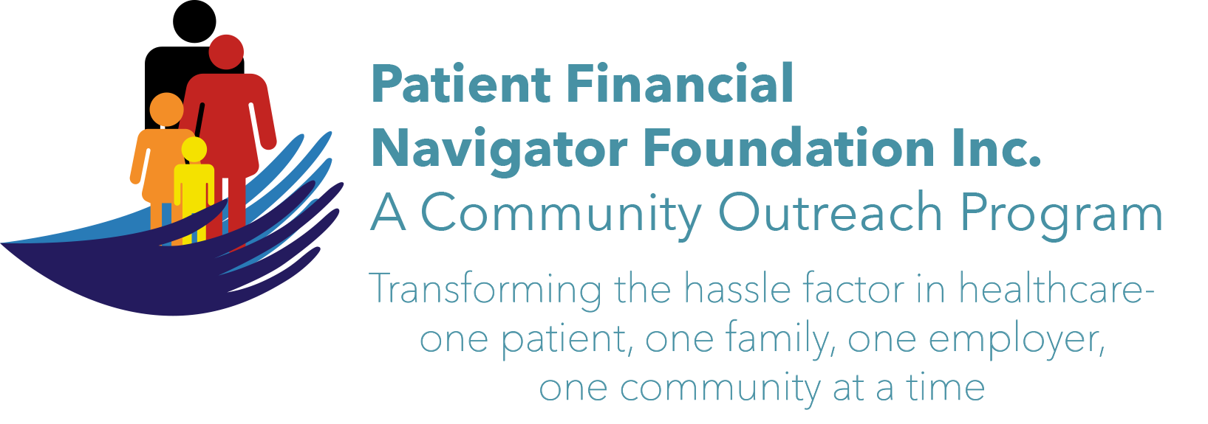 Article for HealthCare Buzz
Times News. Aug 16, 2018
Article – 15
Turning 65: The Work of Being A Patient, Part 2

In Part 1 of this 2-part series, Mark Stevens, Human Resource Consultant/Coach continues to provide guidance in the work of being a patient. “There was an analogy of when we ‘think’ our employer is going to do everything for us – we end up disappointed. To be an engaged patient, it requires the same type of skills and attitudes it takes to do our job. How? 1st) You need to relate to the people around you. You can’t ignore your co-workers, your boss, or your customers. The better those relationships are, the better the work can be. Once you have relationships, you need to use them to get the work done. Don’t be afraid to ask for help. Or to direct your own traffic. 2nd) Get to know your physician and her staff. Then, use them. Ask questions. Don’t be afraid. Learn about your treatment, who you need to know, take notes, and be a part of your care. When you take control, you can help direct traffic in a way that serves your health. 3rd) Learn how to read an explanation of benefits/EOB from your insurance payer. Learn how to read the itemized statement/your bill. Be prepared to ask about estimates/costs for the procedure. Healthcare is complex so is healthcare finance. Don’t just sign things you don’t understand. Finally, being a good employee is an active affair. So too is being a good patient. You are not a victim of healthcare. You are the customer.”

Healthcare is not free. No one asks to get sick. No one asks to have healthcare cost so much and your insurance pay so little or no insurance. No one asks to have their life disrupted with a new diagnosis or change in your health status. No one likes to feel ‘stupid’ when asking questions of your healthcare team – but the alternative is being uninformed with many unpleasant surprises. The work of being a patient requires the patient or their family or designee to be a strong advocate in all aspects of healthcare. Engagement in the process does work, even if it feels uncomfortable! It gets better with practice.

All historic articles & training material are available on the Foundation’s webpage: PFNFInc.com. Day Egusquiza is the President & Founder of the Patient Financial Navigator Foundation, Inc- an Idaho-based, Family Foundation. Mark Stevens resides in Twin Falls.

