social security honors THE NATION’S heroes on memorial day

By Kirk Larson
Social Security Washington State Public Affairs Specialist

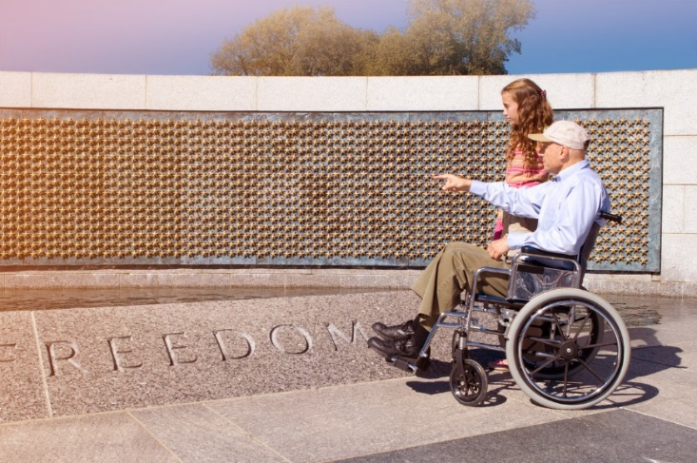

On Memorial Day, we honor service members who have given their lives for our nation. Social Security acknowledges the heroism and courage of our military service members, and we remember those who have given their lives to protect our country. Part of how we honor these heroes is the way we provide Social Security benefits.

The loss of a family member is difficult for anyone. Social Security helps by providing benefits to protect service members’ dependents. Widows, widowers, and their dependent children may be eligible for Social Security survivors benefits. You can learn more about Social Security survivors benefits at www.socialsecurity.gov/survivors.

It’s also important to recognize those service members who are still with us, especially those who have been wounded. Just as they served us, we have the obligation to serve them. Social Security has benefits to protect veterans when an injury prevents them from returning to active duty or performing other work.

Wounded military service members can also receive expedited processing of their Social Security disability claims. For example, Social Security will provide expedited processing of disability claims filed by veterans who have a U.S. Department of Veterans Affairs (VA) Compensation rating of 100 percent Permanent & Total (P&T). The VA and Social Security each have disability programs. You may find that you qualify for disability benefits through one program but not the other, or that you qualify for both. Depending on the situation, some family members of military personnel, including dependent children and, in some cases, spouses, may be eligible to receive Social Security benefits. You can get answers to commonly asked questions and find useful information about the application process at www.socialsecurity.gov/woundedwarriors.

Service members can also receive Social Security in addition to military retirement benefits. The good news is that your military retirement benefit generally does not reduce your Social Security retirement benefit. Learn more about Social Security retirement benefits at www.socialsecurity.gov/retirement. You may also want to visit the Military Service page available at www.socialsecurity.gov/planners/retire/veterans.html.

Service members are also eligible for Medicare at age 65. If you have health insurance from the VA or under the TRICARE or CHAMPVA programs, your health benefits may change, or end, when you become eligible for Medicare. Learn more about Medicare benefits at www.socialsecurity.gov/medicare.

In acknowledgment of those who died for our country, those who served, and those who serve today, we at Social Security honor and thank you.

