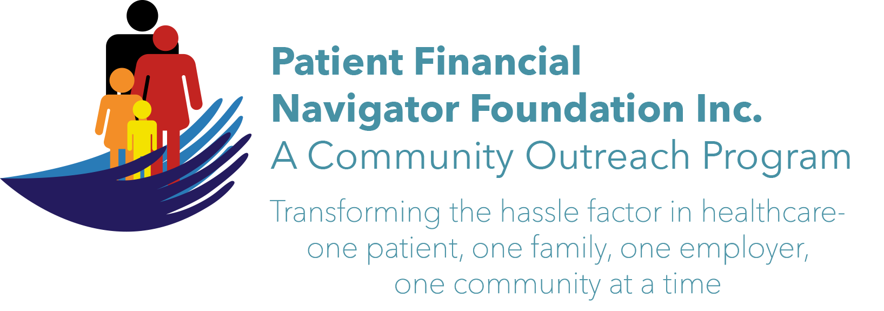 Articles for HealthCare Buzz
Times News. April 18, 2017
Article- 1
“What does out of network mean and how does it impact the patient’s payment?”
Healthcare payments are driven by contracts between payers such as Medicare, Medicaid, primary insurance and healthcare providers. The contracts with the healthcare providers can be optional – such as commercial insurance -or mandatory for Traditional Medicate and Medicaid physicians, home health, outpt services and hospitals.

For the patient and the healthcare provider to receive the best benefit package, there are steps that are occurring in the background.
- The healthcare provider enters into a contract for payment. Inpt is usually based on a flat fee based on the diagnoses= called a Diagnostic Related Grouper/DRG. For hospitals under 25 beds, referred to as critical access hospitals, their inpt payment is a different formula.
- The payor or their broker will work with the employer to ‘sell ‘ a package of inpt, outpt, home health , skilled nursing, physician and related healthcare services. The employer determines which package they want to purchase – deductibles and out to pocket co-insurance amounts are negotiated. “Essential benefits’ that were part of the Affordable Care Act/Obamacare are also included.
- Services purchased by the employer thru the insurance plan are considered ‘in-network.’ All the providers who agreed to take a reduced payment thru the contract are considered ‘in -network.’
- If the patient or family who are covered go to healthcare provider who is not under contract with the employer’s insurance plan, they will pay a much higher out of pocket.
- EX) Patient goes to a surgeon who is not in-network due to a long history with the surgeon.
The patient will owe, at a minimum, an in-network deductible -$6,000 as well as a 2nd Out-of-network deductible of $6,000 PLUS the difference between the amt paid by the insurance and billed charges. The healthcare providers do not have a contract with the provider -so full billed charges will likely be due.

ACTION IDEA:
Always ask prior to any healthcare service – are you contracted with my insurance? There is an opportunity to work with your insurance PRIOR to the healthcare service and ask for an exception – but it is rare. Staying with the network allows for the patient’s deductible and co-insurance amount to be the negotiated rate.
Read your employer benefit package to get additional information.
Additional examples are available on the PFNFInc.Com webpage.

Day Egusquiza, President/Founder
Patient Financial Navigator Foundation, Inc

